Technical Specification for Community
Engagement Mesh Network Initiative

By: Harry Lew
Milad Hajihassan

with the collaboration of Don Loo

© 2017
Summary

In Westernized countries people are surrounded by technology that connects us to our friends, families and workmates. We are also bombarded by media in the forms of videos, live video and audio feeds and advertising in many forms (twitter ads, Facebook ads, sound bites). As a result we take it for granted that we can just turn on our phone and connect with someone we know 24 hours a day and 7 days a week, but in many developing countries people do not have access to mobile devices or can not afford the cost of using the service. Text messaging has emerged as the most cost effective
means of allowing people to connect with each other in mission critical situations. There have been many text message based initiatives in developing countries over the last few years to achieve health, agriculture, education and economic development goals. Most initiatives use bulk text messaging to broadcast information such as crop reports and health advisories to the general population. In countries where the infrastructure is under developed this can be the most effective way of communicating. Often this is one way communications (broadcast) but where two way communications is provided the cost of the communications relative to local incomes is high and born by the individual and the cost and availability of staff to respond remain a challenge. In some countries where people earn on average $2 per day, people can afford to send only 8 text messages per day. While more local support and a collaborative sharing of skills and resources is a more viable solution for increasing the effectiveness of initiatives, the cost of using the existing telecommunication infrastructure remains a challenge. Creating a local mesh network for communications between individuals in small communities is a way of facilitating that communications while reducing the recurring costs. This infrastructure could also supplement the existing and more expensive existing telecommunications infrastructure which has a recurring cost of each message sent.

The project has the objective of creating a design that minimizes the cost of purchasing and installing the infrastructure, minimizes operation cost and maintenance cost and is tolerant to losses of parts of the network due to problems with the system or lack of maintenance. The design will try to draw heavily from component parts available in developing countries. As a result the design does not use the latest versions of the hardware components, but will use designs that are well establish and typically one or two generations behind the current state of the art. Older component parts typically decrease exponentially in price after a few years as the cost of the initial research and the setup cost of the fabrication facilities are covered. Newer designs replace older design making them less desirable to use than more recent designs.

The system is designed to draw heavily from off the shelf component parts as possible so minimal specialized, technical skills are required to assemble parts of the system and to allow for easy replacement and upgrade. Where possible open source software modules were used so that the code be modified to meet the needs of a specific deployment.

The system is designed to be secure and anonymous but still maintain authentication of all users. They key to a democratic process in developing countries. All messages between user are encrypted and an “Signing” system ensures that the message comes from a validated user. Asymmetric encryption is used for the messages that are sent and received. Private and public keys are generated in the client application and public keys are stored on a centralized registration server. Encrypted messages are then sent through a message server .

As encryption of communications is prohibited in some countries and can not technically be imported, the system is designed to be open source so that the encryption features can be compiled and turned on after the hardware is imported as the individual components have no native encryption features installed in their design.

End User Assumptions

The following assumptions are being made about the end users in order to help develop the user interface, feature set and performance specifications of the system.

- Limited technical exposure and capabilities
- Not necessary an English language speaker (instruction and software components to be used by local users must support regionalization of local dialects)
- Many local dialects in a single region
- End users live in rural environments
- They have a low daily income ( $2 per day ) and little disposable income to pay for services
- Service costs are high relative to daily income - most can afford on average to send 8 text messages per day based on income and service charges
- They have limited access to a consistent source of power and may use a centralized power source that is shared for a community – leaving their phone on all the time may not be practical as they have limited ability to charge their phone every day
- 24/7 access anywhere is not necessarily ingrained in the social fabric currently – a phone booth approach where users go to the closest sode when they need to use services (send and receive messages) may be adequate for some community given their ability to afford infrastructure and local social norms
- Outside of the central village complex, farm settlements are spaced far apart and the population density between settlement is fairly sparse – high density placement of mesh nodes may not be necessary due to sparse population densities in area outside of the village community
- Authentication is a primary requirement as trusted sources of information are difficult to determine in some countries which are geo-politically unstable.
- Privacy is critical in regards to promoting free discussion especially in geo-politically unstable regions.

System Performance Assumptions

This system is intended to supplement the existing infrastructure in developing countries in areas when no infrastructure exist or where the cost of using the existing telecommunication infrastructure relative to the daily income is prohibitive. The system must be:

- Simple to set up and install as not all components may not be installed with skilled staff (bolt to a tower, install connector and turn on if possible)
  - require minimum skills to configure in the field (comes self contained and require no setup if possible)
- Fault tolerance as access to skilled staff to repair component parts of the system make be inconsistent and take an extended period of time, and the ability pay for replacement parts might take time
- Be made from components and sub-assemblies which easy to source locally on a relative basis
  - Avoid single source suppliers
  - Benefit from as fall in price due to newer versions of the technology being available
  - have reasonable lead time from out of country suppliers so that local source are not necessary
  - not rely on local manufacturing of advance technology sub-assemblies (ie … circuit boards, 3D printed cases)
- assumes some centralized center of expertise in the country to configure the systems before they are sent out in the field
- supportive a “phone booth” approach where users go to the closest service node when they need to use services (send and receive messages) in communities that desire it based on their usage patterns, local social and cultural norm and/or their ability to afford the infrastructure
- able to run months if not years without maintenance
- designed so that parts that need to be replace as they are used up such as batteries are available locally if possible
- Not have to undergo new regulatory testing to deploy

Secondary system requirement outside of the technical requirement

The system nodes requires a security system so that system components are not stolen. The high level of poverty in some regions makes telecommunications infrastructure likely targets for theft. The theft of underground copper cables and overhead conductors from installations owned by electric utilities, municipalities, telecommunications companies and various railway control systems in countries such as South Africa are a recurring problem. In addition the solar power panels, charging circuits and batteries a potential targets of great value. Physical deterrents around towers and infrastructure placements are required.

Overall Capacity Requirement of the Network

This system in intended to rural environments as opposed to densely populated urban environments though the design should be created to scale.
The following assumptions are being used to create the system requirements:

- population density of the region less that 20,000
- Relative higher density centered around a village, less dense the further out you move from the village – assumes a agriculture based regional economy
- Further out densities of 10 persons per mile or less
- maximum number of messages sent per person per day 50

Comparisons with Similar Existing Systems

There are no complete turn key open source system messaging systems that provide an end to end architecture that covers the client and the infrastructure. This design had as one of its key design objectives the ability to be constructed and customized locally to suit the needs of the community. The system can not be too complex that it require very experience designer and engineers to assemble and build. While this is designed to be a turn key system it is important to note that regulation differ from country to country. As a result there may need to be some customization to comply with the low regulations. Some countries prohibit the importation of technology the encrypts communications for example. The design is open source in nature with all the schematics, code, mechanical drawing, assembly diagrams and instructions provide. There is the assumption there some centralized source of expertise existings in the coutry that can customize the design to match the local regulations.

The Serval Project and the Mesh Potato are two existing projects that are designed to meet very specific goals. The Serval Project was designed to provide a limited form of infrastructure in disaster areas when the existing infrastructure is destroyed. The Mesh Potato was design to provide telephony services in remote communities. While both project can be scaled to provide text messaging capabilities, there are compromise in quality of service, scalability, privacy and authentication that need to be made based on their current designs. The CEMN tries to address those concerns as the system is optimized with those issues in mind.

Serval

http://www.servalproject.org/

The Serval Project was original intended to to be a way of connecting mobile phones together using WiFi or Bluetooth as the communications medium. Phones would be connected together in a peer to peer (P2P) network that would allow communications without the need for telecommunication towers typical of commercial wireless networks. The Serval App on the phone would turn each phone into a node in the mesh network. Text messages, internet traffic and voice over IP (internet protocol) call would be routed over the mesh network with each additional phone in the network relaying the traffic. Through service discover, if an individual phone had cellular or internet capabilities that could access the great World Wide Web (WWW) all other devices in the mesh network would be routed through that phone.

The design has limitation though that make it not quite practical for everyday use. Traffic for the originating phone can only make 5 hops (hop up to 5 phone in distance from the source). With the maximum spacing between individual phones of between 10 metres (nominal) to 30 metres (only with class 2 WiFi tansceivers which are not typically installed in handsets) the maximum range is between 50 metres and 150 metres of coverage. To extend the range the designers have create Mesh Extender nodes. Mesh Extender essentially create a WiFi hotspot with an omni-directional antenna and then use long range radios (RFD900/RFD868 UHF packet radio) for up to 4km range line-of-sight and approximately 200m indoors. The system has faced challenges in that the radio are regulated and in some cases it is difficult to import them into a disaster area if they have not already been pre-certified.

The power consumption as a result of installing the App is very high. There have been a number of comments in the Android Store commenting on the excess battery draw and personal experience by the designers of this project confirm the battery draw down issue. Shutting down the Serval program does not seem to eliminated excessive power draw issue.

In addition many phones have to be “root” (security feature of the phone disabled) in order to give the App the access it needs to set up the phone as a relay node for traffic in the peer to peer mesh network setup between the handset. Recent updates to the Android operating system making the ability to get the App to work even after rooting is an issue that the designer have discussed openly. The designers are moving to the Mesh Extender model is a result of this.

Preserving the privacy of the users and the content of the text messages and voice conversations are not a primary function of the system. It is intended to operate in area where a disaster has occurred and only be run for short periods of time.

Serval is an open source hardware and software initiative. The Mesh Extender is a recent addition to the design. The mesh extender uses custom circuit boards, so medium to large size runs are necessary to make producing the boards cost effective.

Summary of Pros and Cons of Serval System

Pros and Cons

- Serval requires many phone to be rooted in order to run.

- Most recent release of Android prevent the client software from running

- The software causes the battery on the phone to deplete more quickly than without the software installed even when the software is not active

- Message relaying between phone is limited to 5 hops (optimal distant is therefore 50 meter to 150 meters) depending on the power of the transmitter radios in the handsets

- Moving to Serval Extender product which implements a WiFi hotspot with long range radios to link Serval Extender nodes has regulatory issues in some countries

Mesh Potato

https://villagetelco.org/mesh-potato/

The Mesh Potato is a WiFi node that is intended to provide low-cost telephony and Internet in areas where alternative access either doesn’t exist or is too expensive. It is a marriage of a low-cost wireless access point (AP) capable of running a mesh networking protocol with an Analog Telephony Adapter (ATA). It main objective to provide telephone services in remote communities though the nodes can act as WiFi access points. The project is open source with the software and hardware design components available on line. The Mesh Potato was intended to be a mass produced product. It uses custom printed circuit board. It has one Ethernet port, one telephone jack port and one WiFi port with an internal omni-directional antenna.

Overview
- Atheros AR2317 system on a Chip (SoC)
- Silicon labs FXS port chipset
- MIPS 4k processor 180 MHz
- One 10/100Mbit LAN port
- 8 MByte Serial Flash EEPROM
- 16 MByte RAM
Wireless LAN
- IEEE 802.11b/g
- Frequency Band : 2.4 to 2.462GHz
- Antenna Type : Internal Omnidirectional PCB Antenna
- Transmit EIRP power: 1-24 Mbit 20dBm or 36-54 Mbit 17dBm
Interfaces/Ports
- LAN Port : 1 x RJ-45 (Ethernet Port)
- FXS Port : 1 x RJ-11 (Telephone jack port)
It is mature design have initially be developed in 2009. Because it is mass produced it is a cost effective means of deploying a mesh network. It was not really setup to implement a message server architecture but it can be modified.

We did not choose this particular system to be the technology for the nodes of the mesh network because the internal omni-directionalc antenna limits the range of the WiFi coverage without using repeaters. Though it is open source and reasonably cost effective when produced in larger quantity, if the community installing the system requires custom modifications to the hardware, the design is not easy to incrementally scaled without a large up front investment to make new circuit boards if only a small number of units are required.

Summary of Pros and Cons of Mesh Potato System

Pros and Cons of Mesh Potato

- Well established design have been around since 2009

- Open source design
- low electronic systems cost if manufactured in medium to large quantities
- not easily customizable if only a small number of units are required as it requires the investment in a production run to get volume discounts
- limited configurability of the antenna of the system as it is embedded in the system and not easily accessible
- limited ability to extend the range of the design do to lack of access to the antenna of the embedded system

FireChat

Firechat is not a complete system such much as an application that is designed to not rely on the existence of traditional telecommunication infrastructure. Firechat uses WiFi and Bluetooth to create a localized peer to peer network between the phone of users using the FireChat App in the vicinity.

The intention of the system is that phones running the App are automatically connected directly with one another, creating their own network for public and private communications. The more people use it, the bigger and faster your network becomes. And when a phone does have access to a reliable Internet connection or cellular network, FireChat helps reach people worldwide.

FireChat creates a mesh network using Bluetooth and peer-to-peer WiFi. FireChat transmits messages and pictures offline between devices that are located within 200 feet of one another.

“Thanks to FireChat’s innovative multi-hop and store-and-forward capabilities, FireChat users form a network that increases in size with the number of devices. It allows messages to hop from one device to the next in order to reach the recipient(s). This is why the more people use FireChat, the better and the larger the network becomes (unlike with cellular networks).

On the mesh network, messages are transmitted seamlessly from one device to the next in order to reach the recipient(s). When an Internet connection or cellular network is available, FireChat uses them to reach remote recipients.

Public messages are visible by anyone. Private messages are encrypted and can only be seen and read by the sender and the recipient.”

The limitations with this system is that Bluetooth paring of devices are not always easy and straight forward. Maintaining the link consistently can also be an issue. A number of reviews of the App in the Android App store report that the system did not work consistently without an existing internet connection or cellular network, which defeats the purpose of the implementation. It can also drain the battery excessive even with Bluetooth and WiFi off and the phone in airplane mode. This is something the designer experienced directly when testing the App.

The power drain and the inconsistent connect made this existing App not a practical choice for deployment with this system.

Summary of Pros and Cons of FireChat

Pros and Cons of Firechat

- only an Peer-to-Peer application

- inconsistent pairing using Bluetooth

- inconsistent Bluetooth connection once paired

- still rely on wireless infrastructure for greater coverage

- inconsistent without wireless infrastructure

- excessive power drain shortening the life of the phone on a charge

Other Encrypted Chat Applications

These are also a number of other encrypted Apps that are designed to provide secure chat features such as ChatSecure (https://chatsecure.org), Adium (https://adium.im) , Signal (https://play.google.com/store/apps/details?id=org.thoughtcrime.securesms&hl=en ) and many more. Some of these programs use sophisticated encryption and authentication schemes that are difficult to implement or replicated without extensive experience. The do not have reliable access to the internet to function though so these systems were not considered as comparable turn key designs.

Overview of Chat Client from the User’s perspective

Process for Installing and Launching program for first time

- The client App comes installed on the phone or is downloaded from a trusted source. Due to the limitations of access to the internet in some regions distribution may be through a flash drive at a local civic centre through a USB OTG port or a computer.
- On launch the App shows Login Activity which is a sign in screen letting the user login in they already registered.
  - The App asks the user to enter a username and a password.
  - There is a button to SIGN IN and a REGISTER button to register a new user
  - The app ties to connect to messaging server once the user clicks on SIGN IN using the corresponding username and password. The app shows a dialog message that the user is authenticated if the credentials are correct and takes the user to contact activity.
  - The App takes user to the Registration Activity if user clicks on REGISTER button

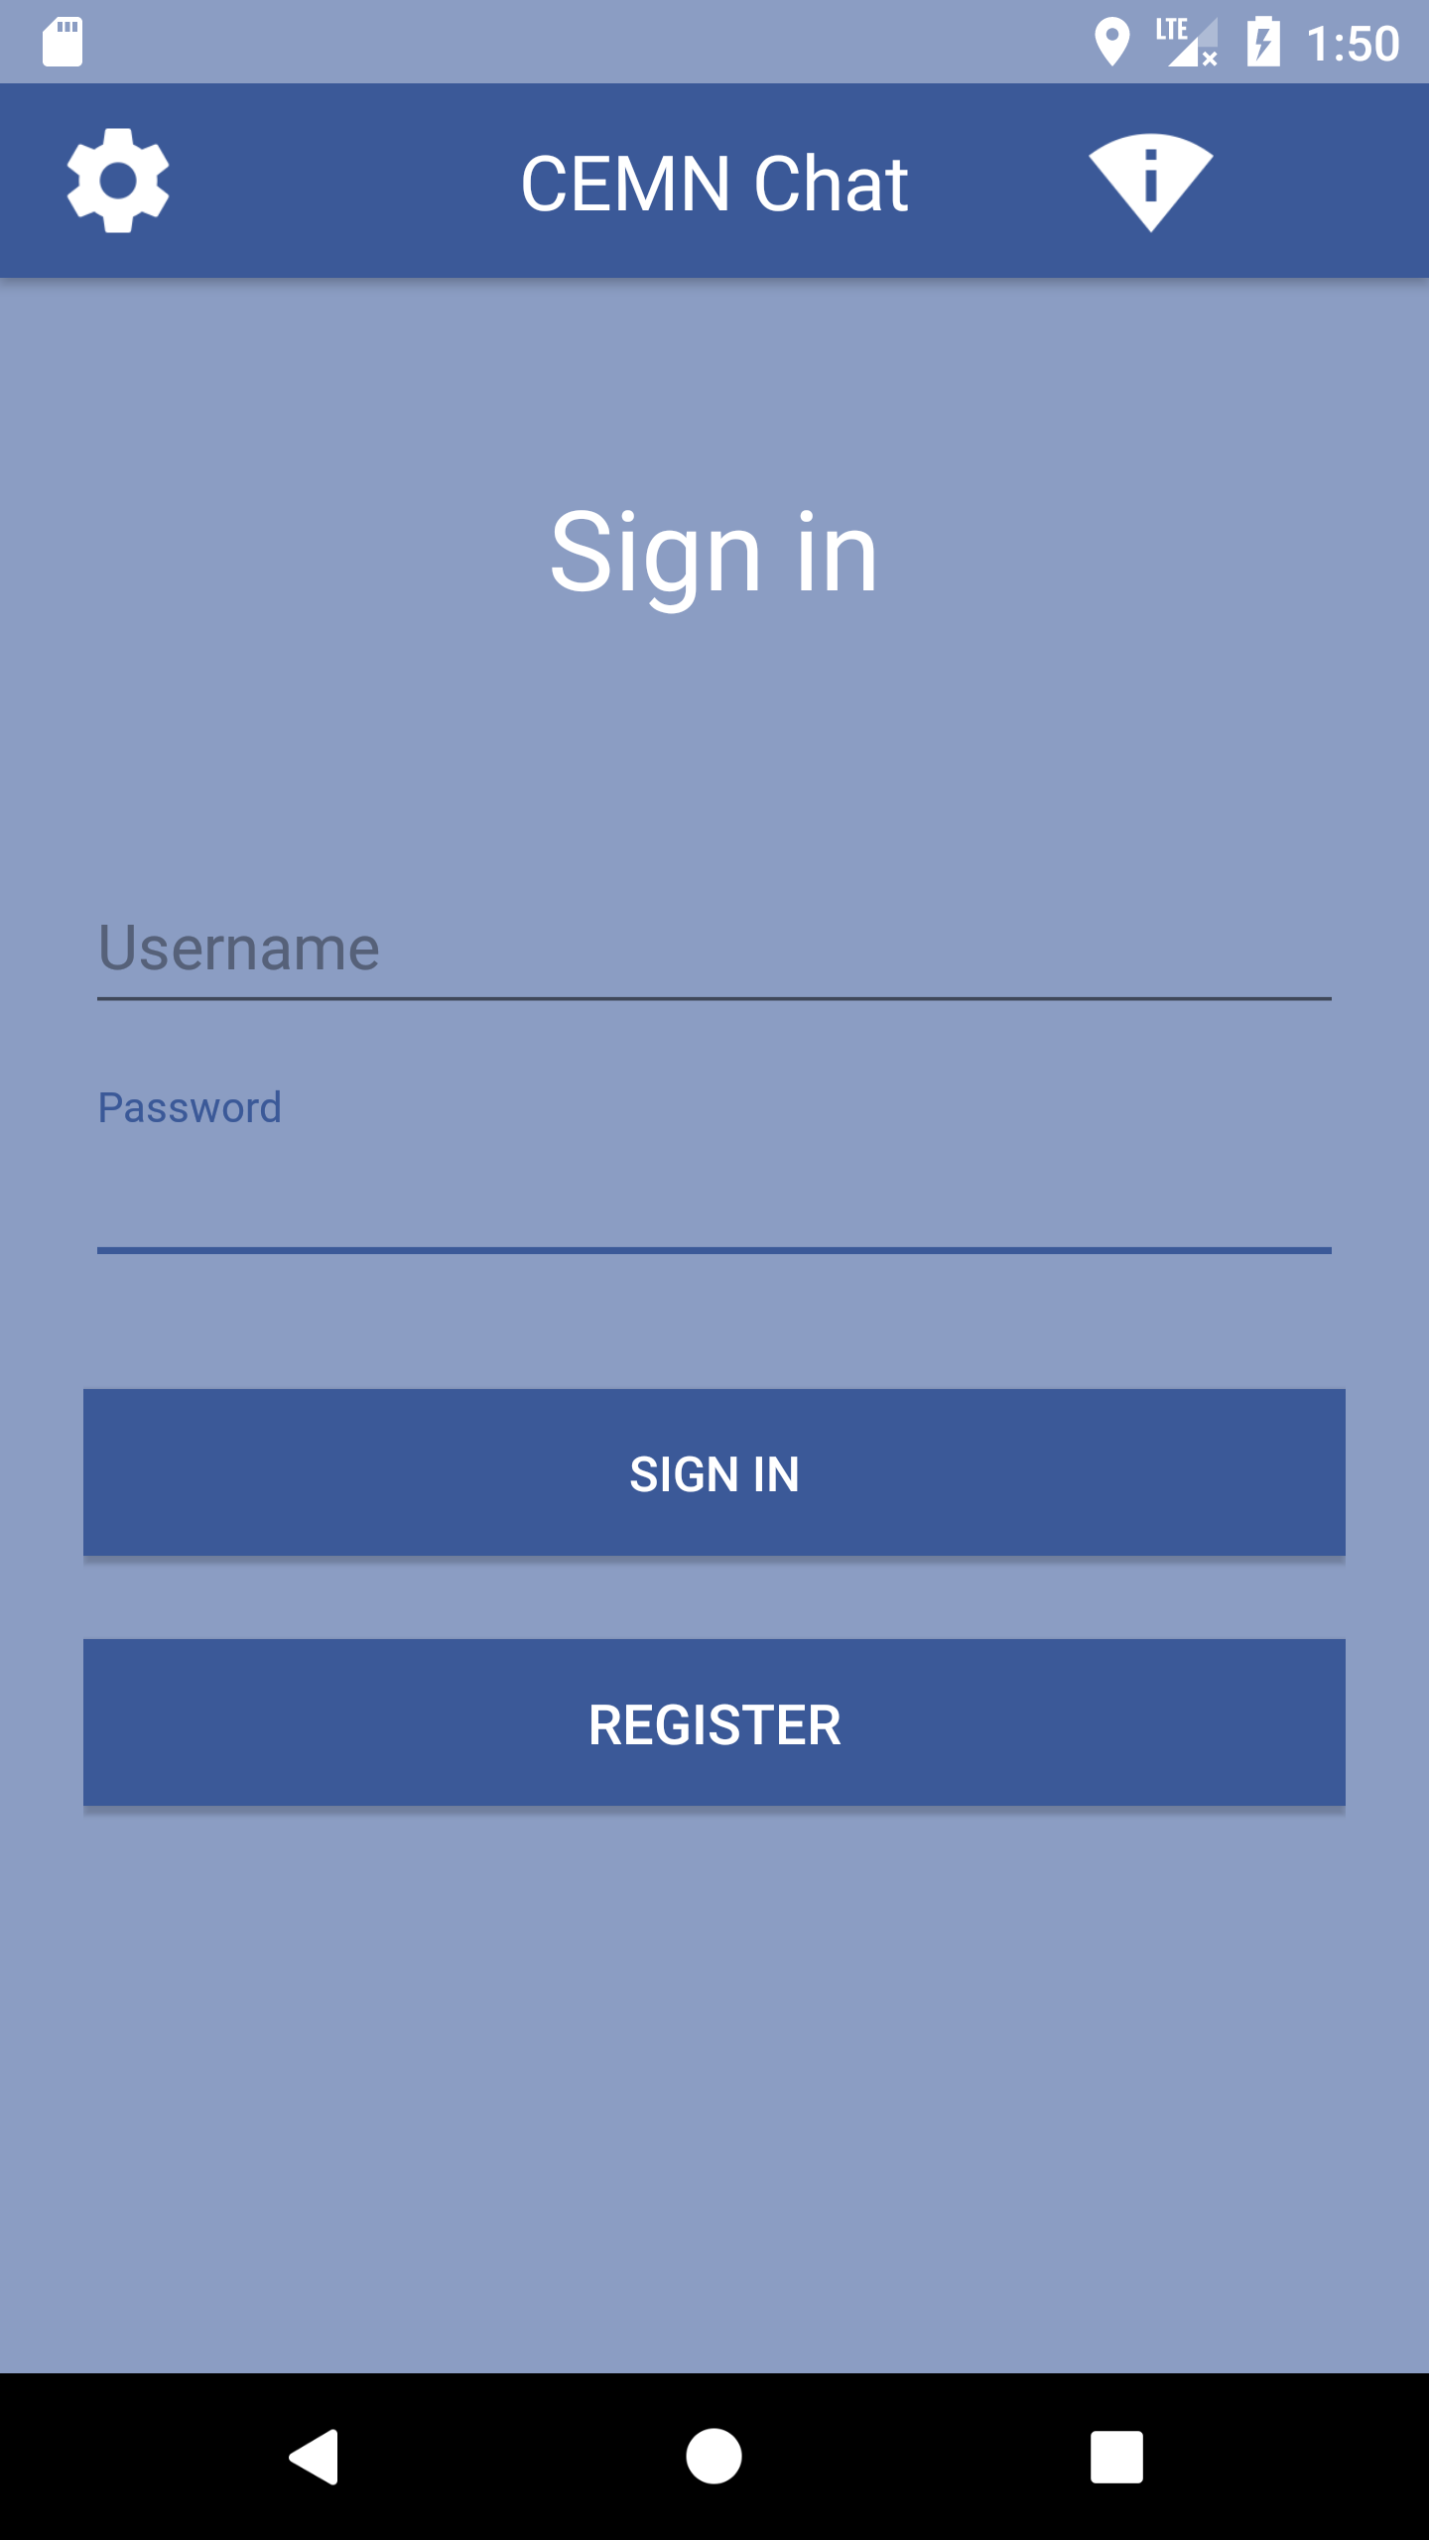

Registration Activity

- The Registration screen has a text field for a user name, two text fields to enter the pass word twice for validation, a button to register the user name and pass word with a registration server and a cancel button to clear all the fields.

  - The Registration screen asks the user to enter a user name and a password (twice to ensure that they match). Each letter of the pass word appears for a second and then is obscured to ensure privacy.
  - When the user presses the REGISTER key the user name and pass word are encrypted and stored in a secret location on the Android phone using shared preferences. The App also generates a 2048-bit RSA Private and Public Key using the Android Crypto library functions.
  - The user name, Password and the corresponding Public Key are then send to the Registration Server. The registration server confirms that the user name is available and not already used. The public key and the user name uniquely identify the user to the Registration and Message Server. The Password is sent as an AES-128 encrypted string.
  - Each user must sign in using their Password. In developing countries, a single family may be sharing phone so multiple users are possible.

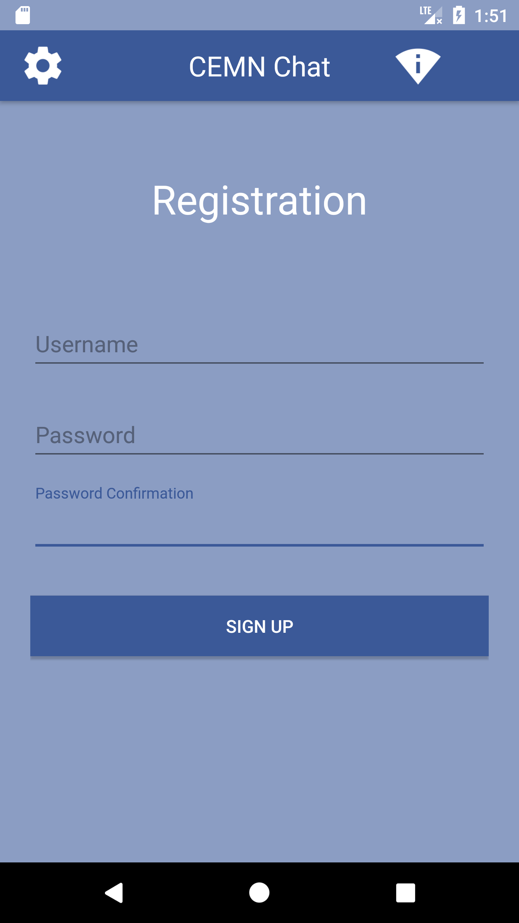

Contact Activity

- The contact activity screen of the App has a title bar across the top with a GEAR icon in the upper left-hand corner of the screen to access the STETTING menu for the App, the title “CEMN CHAT” in the middle of the title bar, an icon showing the status of the WiFi to the right of the title and then an “X” icon in the upper right corner to indicate a way to exit the program.
- Below the title bar is a text edit field to enter the name of a recipient. To the left of the text field is an icon of a HEAD to indicate access to a CONTACT list.
- There is a CONNECT button that can be used to find the recipient user through their username and start the chat. The registration server starts searching for the recipient username entered in text edit field once the user hits CONNECT button and opens the Chat Activity if recipient username exists.

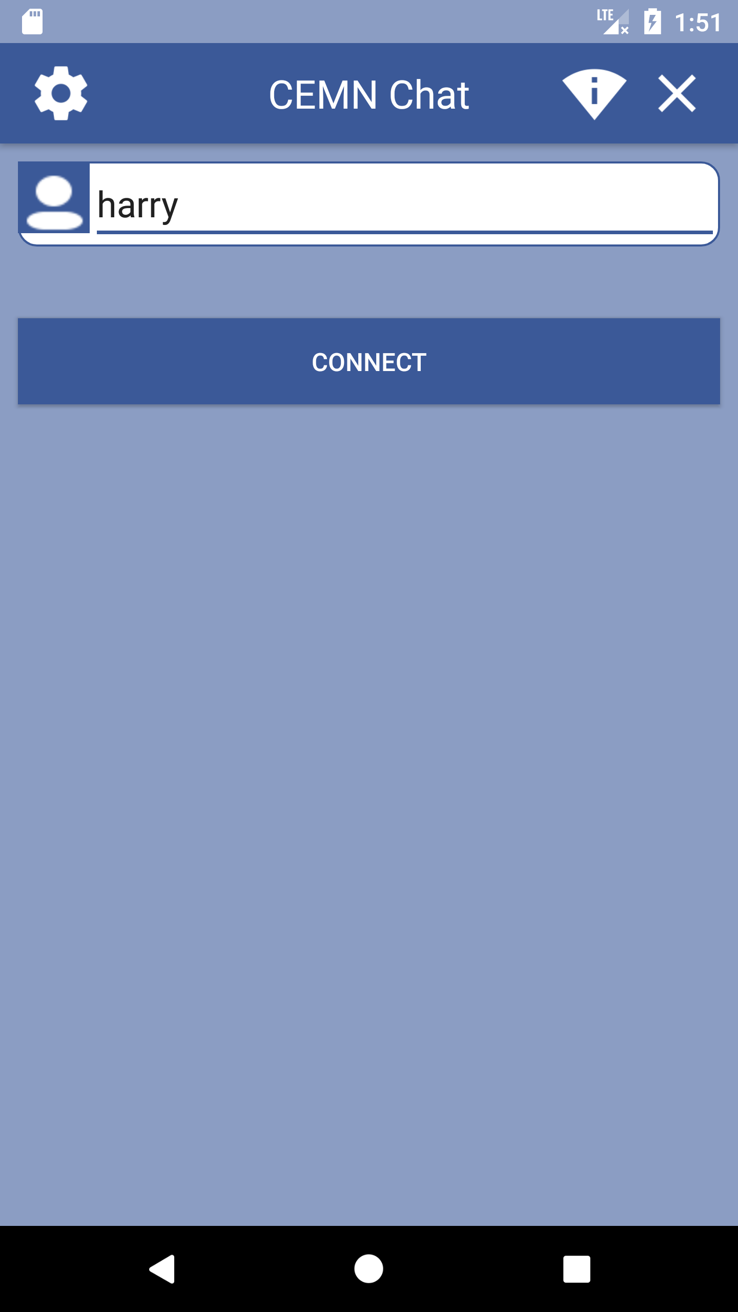

Main Chat Activity

- The chat activity screen of the App has a title bar across the top with a GEAR icon in the upper left-hand corner of the screen to access the STETTING menu for the App, the title “CEMN CHAT” in the middle of the title bar, an icon showing the status of the WiFi to the right of the title and then an “X” icon in the upper right corner to indicate a way to exit the program.
- At the bottom of chat activity screen is a multi-line text field. The user can enter a text message in this field. Pressing enter sends the message to the message server located on the network. The sent message is encrypted using the RSA 2048 method. Each message is assigned a unique ID by the CEMN App that will be used in the acknowledgement message sent back from the Recipient’s copy of the CEMN App. The message is also signed with a digital signature. The Hash of the text message is calculated using SHA-256. The Hash is then encrypted using the user’s private key and RSA-2048. That digital signature is added to the XML documents that forms the message. How the signature is verified is describe below in the receiving message process.

The field also displays any incoming message. Incoming message are also encrypted using the RSA 2048 method. First the digital signature is extracted from the XML document that forms the message. The Public Key for the sender is then used to decode the Digital Signature. The decoded digital signature should be the same of the Hash as the message calculated once it has been decrypted. The message first needs to be decoded using the locally stored user’s Private Key and RSA-2048 encryption. The Hash of the decoded text of the message is then calculated using SHA-256. The Hash from the decoded digital signature is then compared against the Hash calculated from the text of the message. If the two values are the same the message come from the sender’s who Public Key is associated with the User Name. The text of the message is then safe to display in the App edit text box. If the signatures do not match the user will be notified and the text in the message will not be show and the buffer purged of the text. Incoming and outgoing message should be displayed in a different color or reverse video to clearly indicate what is being received and what is being sent. (NOTE: Conversations on the phone are not persistent like SMS messages. Only the less few lines of the conversation are displayed on the screen and once the App is closed down or the phone re-started the conversation text is lost. This is to ensure there is no record of the conversation on the phone. User should be able to do screen shoot if they need to preserve a copy of any text on the screen.) The messages can also be setup to intentional disappear in 24 hours or some set time period.

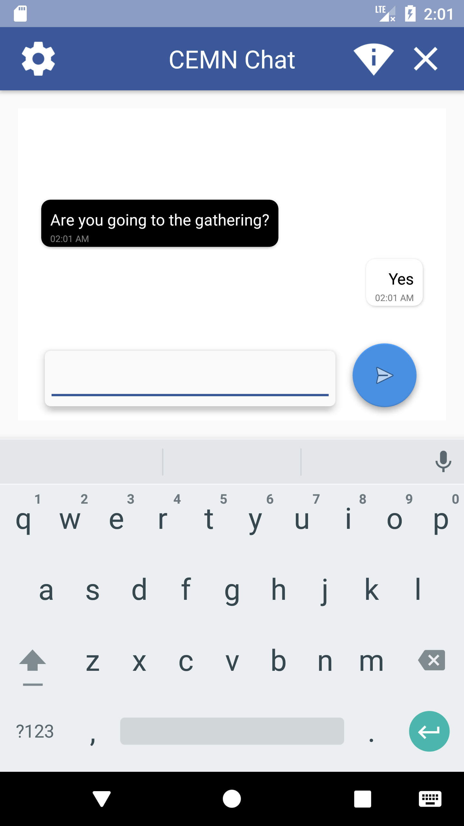

Contact list Activity

- This section is currently under development and will be added.
- When the CONTACT icon is hit a new CONTACT activity window appears.
- The activity window contains a list of the existing contacts on the phone. The user can scroll through the list using a scroll bar on the right of the list box. They can highlight a contact by touching the appropriate name on the list.
- To select the highlight name the user need to hit the SELECT button below the list box. This ensure the user need to confirm the recipient. The alternative is to select the name once you touch the name. On phones with small screens this means a wrong name may be selected and they will have to hit the CONTACT icon again and start the process again.
- When the SELECT button is hit the CONTACT dialog box is dismissed and the information transferred to the text edit field on the previous screen for the recipient.
- Next to the SELECT icon is an ADD icon. Hitting the ADD icon brings up a DIALOG box to enter the name of a new contact.
- The ADD CONTACT dialog has a single line text field to enter a new contact user name and a ADD button and a CANCEL button. Hitting ADD adds the user name to contact list and dismisses the dialog. Hitting CANCEL dismisses the dialog box.
- When the ADD button is hit the user name of the contact the user is trying to add is sent to the Registration Server. The Registration Server confirm the user name exists in the database and send back the Public Key association with that user name back the user’s App. The Public Key is then stored with the User Name in a Key Store on the device.

Settings Activity

- This section currently only contains a REGISTRATION and a CHANGE password and username choices but more options will be coming. Password protecting the contact list might be one other option.
- The REGISTRATION button or checkbox item allows the user to register addition users for this App. This is designed to support a family or group of family. That allows the recipient to know who is sending them the message.
- PASSWORD allows a user to change their existing pass word stored on the Registration Server. They need to confirm their existing PASS WORD before the Registration Server will allow them to change their existing pass word.
- Selecting PASSWORD brings up a dialog with the following text field for the user name, old pass word and two fields for the new pass word in order to validate it and an CHANGE and CANCEL button. Hitting CHANGE button sends a change request to the Registration Server. Hitting CANCEL dismisses the dialog. If the change is successful a box comes up letting the user know the change was successful otherwise a box comes up with the appropriate error message.
- A similar dialog comes up when the user selects the change USER NAME. The text fields are USER NAME, NEW USER NAME and pass word. There is a CHANGE and CANCEL button. Selecting CHANGE sends the request to the Registration Server. Selecting CANCEL dismisses the dialog.
- This section is still under develop so the options here are only tentative.

Basics of Privacy and Encryption

Privacy and authentication is important to everyone but especially in developing countries where the geo-political climate is not certain. As a result it is important to briefly explain a number of basic cryptography terms and principle to explain the need for and the implementation method for each cryptographic technique.

Hashing is a method of converting a string to a series of numbers of a fixed length. The process a complex and is intended to be work only in one direction as the process can not be reverse to recover the original string. If constructed properly a unique string will only produce a unique series of numbers. Hashing is typical used to encrypt data that does not have to be decoded again. By comparing the output of a hash function data can be verified. A good example of this would in the verification of pass words.
It is insecure to store the pass words in a database in case the security of the database is be broken. If the actual strings that make up the pass word is stored in the database once the security is broke one could simple read the pass word strings out of the database. It is more secure to store the results of a hashing function in the database. When the user enters their pass word, the string for the password is passed though the same hashing function and the result and compared with the previously stored result in the database.

Symmetric Encryption

In Symmetric Encryption a mathematic algorithm is used to encrypt the information and the reverse of that algorithm is used to decode the encrypted information. The encryption technique is known to be symmetric as the reverse technique is used to decode it. A simple example of a symmetric encryption technique is a simple letter replacement cipher. Each letter of the alphabet is replaced by another letter in the alphabet. Usually a key, an agree upon series of letters and numbers is used to decode the message. For the replacement cipher the legend details what letter was replace with which letter. In more advanced symmetric algorithms the key is made up of a long series of letters and numbers. The sender and the recipient of the encode message must protect the key as anyone can decode the message if they have the key. Typically, when a message is sent through the internet the key is sent by mail or by phone conversation to preserve the secrecy of the key.

Asymmetric Encryption

In Asymmetric Encryption each user of the system generates a Public and Private Key. The keys are simply large numbers that have been paired together but are not identical (asymmetric). The user’s Public Key is then shared freely among their friends. When a friend wants to send that user a message they combine the Public Key and the text of their message and run it through the encryption algorithm. The output is typically a series of scrambled letters and numbers. The friend can then send the message to the recipient using standard email or text messaging methods. Anyone can intercept the message but a recipient can only decode the message if they have the Private Key. Technically either of the keys can be used to encrypt a message; the opposite key from the one used to encrypt the message is used for decryption. The encryption method is sophisticated enough that it would take years using a super computer to try all the potential variations that could break the code. Encryption techniques that use 2048 bits or more are currently considered the most secure though 1024 bit is still considered adequate. 1024-bit encryption for example is used to secure many internet bank transactions. As computer power increases the number of bits required to be secure increases. No mathematical encryption algorithm is considered totally secure. Given enough time any code can be broken. In terms of the most sophisticated algorithms the time to break the code can be measured in decades so they are considered reasonably secure.

“Many protocols like SSH, OpenPGP, S/MIME, and SSL/TLS rely on asymmetric cryptography for encryption and digital signature functions. It is also used in software programs, such as browsers, which need to establish a secure connection over an insecure network like the internet or need to validate a digital signature. Encryption strength is directly tied to key size and doubling key length delivers an exponential increase in strength, although it does impair performance.”

“RSA (Rivest-Shamir-Adleman), the most widely used asymmetric algorithm, is embedded in the SSL/TLS protocol which is used to provide communications security over a computer network. RSA derives its security from the computational difficulty of factoring large integers that are the product of two large prime numbers. Multiplying two large primes is easy, but the difficulty of determining the original numbers from the total -- factoring -- forms the basis of public key cryptography security. The time it takes to factor the product of two sufficiently large primes is considered to be beyond the capabilities of most attackers, excluding nation state actors who may have access to sufficient computing power. RSA keys are typically 1024- or 2048-bits long, but experts believe that 1024-bit keys could be broken in the near future, which is why government and industry are moving to a minimum key length of 2048-bits.”

Authentication

Beyond privacy of the message it is important to ensure the message comes from someone you trust and it is from who they say they are. Digital signatures are used to ensure the message came for the person who they say they are.

“Digital signatures are based on asymmetric cryptography and can provide assurances of evidence to origin, identity and status of an electronic document, transaction or message, as well as acknowledging informed consent by the signer. To create a digital signature, signing software (such as an email program) creates a one-way hash of the electronic data to be signed. The user's private key is then used to encrypt the hash, returning a value that is unique to the hashed data. The encrypted hash, along with other information such as the hashing algorithm, forms the digital signature. Any change in the data, even to a single bit, results in a different hash value. This attribute enables others to validate the integrity of the data by using the signer's public key to decrypt the hash. If the decrypted hash matches a second computed hash of the same data, it proves that the data hasn't changed since it was signed. If the two hashes don't match, the data has either been tampered with in some way (indicating a failure of integrity) or the signature was created with a private key that doesn't correspond to the public key presented by the signer (indicating a failure of authentication).”

A digital signature also makes it difficult for the signing party to deny having signed something. This is known as Non-repudiation.

“Digital signatures are typically made in a two-step process. The first step is to use a secure hashing algorithm on the data. SHA-2 algorithms would be an example of that. The second step is to encrypt the resulting output with the private signing key.

Thus, when a signature is verified by the public key, it decrypts to a hash matching the message. That hash can only be decrypted using the public key if it were encrypted with the private signing key. “

Implementation of Privacy and Authentication

Certain aspects of the system design that affect privacy and authentication are distributed and other aspects are centralized and hosted on servers attached to the mesh network. Generation of the asymmetric keys are accomplished in the copies of the CEMN custom application installed on the mobile devices. Publication of the public keys that are necessary to identify a recipient are done on a Registration Server hosted on a node on the mesh network. Interactions with the Registration Server are encrypted using a symmetry encryption scheme and signed to ensure that hackers can not modify or re-direction the transmission of messages.

Messages sent through the mesh network are handled by an XMPP (Extensible Messaging and Presence Protocol) Message Server hosted on a server connected to one of the nodes in the mesh network. XMPP is a client-server architecture. Messages are relayed through a server. The client pushes messages on to the server and is responsible for polling the server to find out if any new messages are available for the recipient. When an XMPP server is connected to the World Wide Web and able to access addresses outside of the mesh network it is possible to add the extras security of using TLS (Transport Layer Security) and SSL (Secure Sockets Layer) encrypted channels. TLS and SSL typically require access to a third party trusted source that will validate the SSL certificate of the website the user is trying to visit and then set up the TLS/SSL secured transmission channel. Registration of an SSL certificate with a trusted source usually involves paying a recurring fee. In isolated regional networks that can not access the greater World Wide Web access to third party trusted sources for SSL certificate validation is not possible. While it is possible to use Self Signed SSL certificates there is not way to completely validate the authenticity of this kind of certificate.

The XMPP Server implementation was chosen as it simplifies the formatting of the messages which are typically broken down into smaller packets and then transmitted over the network. The XMPP Server handles temporarily storing and forwarding the message on to the recipient. The XMPP Server and Client software is open source and is a mature technology. Variations of XMPP technology are implement in programs such as WhatsApp, Yahoo Messenger, Facebook Messenger and early versions of Google Chat

As it is not possible to use TLS or SSL encrypted transmission channels the text in the messages will be encrypted using an asymmetric encryption algorithm. For extra safety many email clients/apps offer encryption of the text of the email on top of the TLS/SSL encryption channel communications provided. Pretty Good Privacy (PGP) encryption is one popular open source email encryption technique. An open source version of PGP call GNUPG exists. The PGP encryption process is complex to understand and the specification provides for many services that are not necessary for basic secure communications. The designers want to make the system simple enough that it could be modified without having an extensive knowledge of encryption without sacrificing privacy and security of the message transmission. So, the choice was made to use a simpler but secure encryption mechanism for the text content of each message. It should also be noted that some countries have regulations that prohibit the importation of technology that encrypts communications. While the designers make no declaration on whether the system compiles with the regional regulation, it does note that the design is open source and therefore can be modified to meet the needs of the end user.

The client (Messaging App) for this system design was written for the devices that use the Android operating system. The Android operating system has the largest installed base across a range of phones in different price points. The Apple IOS system while popular in developed country is quite expensive and unaffordable for many end users in developing countries. While the client was written with Android operating system in mind it can be ported to other systems. The designers have tried to reduce system complexity while maintaining key features that are critical to end users – low cost, availability, authentication and privacy.

As a result, the system is using the Android Cryptography APIs provide through Android studio, A combination of symmetric and asymmetric keys and hashing functions are used in the design of the client software. In addition, the Android API used to securely store keys are used to store private and symmetric keys on the actual handset. Physical access to the handset is necessary to access the keys. Many of these cryptographic API has existed since the first early releases of Android so older phone will be compatible with the CEMN Application.

“The most widely-used algorithm used in symmetric key cryptography is AES (Advanced Encryption Standard). It comprises three block ciphers, AES-128, AES-192 and AES-256, each of which is deemed sufficient to protect government classified information up to the SECRET level with TOP SECRET information requiring either 192 or 256 key lengths. Other common symmetric encryption algorithms include Blowfish, Twofish, Data Encryption Standard (DES), 3DES and RC4, although recent attacks have revealed weaknesses in the RC4 algorithm.”

The main disadvantage of symmetric key cryptography is that all parties involved have to exchange the key used to encrypt the data before they can decrypt it. In small isolated network such as the CEMN network where aspects of the design are pre-determined the keys can be build into the clients and servers ahead of time. While the current design is totally open source to demonstrate the concepts, an actual implementation would change the symmetric encryption method and keeping it the keys secret. This system design will use AES-128 for all symmetric encryption.

“One of the most common asymmetric encryption algorithms is the Diffie-Hellman key exchange, which allows two parties to exchange cryptographic keys in a secure manner regardless of whether the communication channel is public or private. The RSA (Rivest, Shamir and Adleman) asymmetric algorithm is another widely used asymmetric encryption example; it is often used in electronic commerce protocols such as SSL, and is believed to be secure given sufficiently long keys and the use of up-to-date implementations.”

RSA 2048 is used for all asymmetric encryption in this system design. The Android Cryptographic API supports generating RSA 2048 public and private keys and provides methods to encrypt and decode messages using RSA 2048. Note that RSA has a limitation of 117 bytes of data that can be encrypted for RSA 1024 and 200 bytes of data for RSA 2048. RSA is typically not used to send large blocks of data. For large blocks of data the data is encrypted using a symmetric key and then the encrypted block of data is sent with the symmetric key encoded in RSA 1024 or RSA 2048 to the recipient. The recipient decodes the asymmetrically encoded symmetric key and then uses the decoded symmetric key to decode the large block of symmetrically encoded data. A new symmetric key is generated each time a block of data is transmitted from the sender to the recipient. The designers of this project have decided to the keep the user experience of the SMS system which has a character limit of 140 bytes. The 140 bytes is due to the fact the SMS messages are transferred in the frames for the control commands for the network traffic when there is idle time in the transmission of command codes. SMS is not guaranteed to delivered in a timey manner as a result because the control codes take precedent. Depending on the amount of traffic a SMS message can be delay minute or hours if there are a large number of messages and a large number of network control codes that need to be transmitted.

“MD5 and SHA-1 were widely used hash algorithms, but are now considered weak and are being replaced by SHA-224, SHA-256, SHA-384 or SHA-512, sometimes collectively referred to as SHA-2. Microsoft, Google and Mozilla have all announced plans to remove SHA-1 support from their browser products. Although no attacks have yet been reported on the SHA-2 variants, they are algorithmically similar to SHA-1 and so a new hash standard, SHA-3, will be selected in a similar way to AES in the next few years.”

All hashing will be done using SHA-256 in this design.

[Note: Where possible all encryption has been done using open source tools and libraries. Even though the tools are freely available it is important to note that some jurisdictions prohibit encrypted communications and other jurisdictions prohibit the importation or export of encryption methods that can not be easily broken. The designers make no claim on the appropriateness of the encryption used in this design in regards to deployment in specific jurisdictions. Users deploying the system should comply with the local regulation. The designers are not security researchers so no explicit claims are being made of the absolute security of the encryption methods and the integrity of the system. The designers have tried to highlight the key privacy and security issues and implement methods to address those issues. Determined hackers can break any system given enough time and resources. This design attempts to put in place measures that can be implemented easily with minimal encryption and cyber-security knowledge. The designers have drawn from the best practices from existing more sophisticate systems and protocols in this design.]

“A digital signature in its simplest description is a hash (SHA1, MD5, etc.) of the data (file, message, etc.) that is subsequently encrypted with the signer's private key. Since that is something only the signer has (or should have) that is where the trust comes from. EVERYONE has (or should have) access to the signer's public key. So, to validate a digital signature, the recipient (1) calculates a hash of the same data (file, message, etc.), (2) decrypts the digital signature using the sender's PUBLIC key, and (3) compares the 2 hash values. If they match, the signature is considered valid. If they don't match, it either means that a different key was used to sign it, or that the data has been altered (either intentionally or unintentionally).”

All hashing for digital signatures will be done using SHA-256 in this design.

Implementation Details of the Chat User Client

- Registration USER NAME, PASS WORD and unique ID returned from the Registration Server is Encrypted using AES-128
- Outgoing messages to the Message Server are encrypted and decoded using RSA-2048 and incoming messages from the Message Server to the client App are similarly encrypted and decoded using RSA-2048
- The USER NAME and the PASS WORD are used provide Authentication of users. It prevents users form pretending they are some else so that they can send and receive message intended for someone else.

Encryption

The client (Messaging App) for this system design was written for the devices that use the Android operating system. The Android operating system has the largest installed base across a range of phones in different price points. The Apple IOS system while popular in developed country is quite expensive and unaffordable for many end users in developing countries. When client was written with Android operating system in mind it can be ported to other systems. The designers have tried to reduce system complexity while maintaining key features that are critical to end users – low cost, availability and privacy.

As a result, the system is using the Android Cryptography APIs provide through Android studio, A combination of symmetric and asymmetric keys are using in the design of the client software. In addition, the Android API used to securely store keys are used to store private and symmetric keys on the actual handset. Physical access to the handset is necessary to access keys.

It is important to briefly explain an number of basic cryptography terms and principle to explain the need for and the implementation method for each cryptographic technique. The most important terms are:

- Hashing
- Symmetric Key Encryption
- Asymmetric Key Encryption

“Encrypting: encryption transforms the plaintext into something that cannot be understood - something that doesn't have any meaning. Something unintelligible. You encrypt the message/plaintext by using an algorithm and a key. The output (the ciphertext) always depends on the key. The essential thing about encryption is that you can always recover the plaintext (if you know the key/password), and given a key/password you have only one plaintext. So, you can think of encryption/decryption as a way to move back and forward between you plaintext and your cipher text (using a key).
Uses: Encryption is good if you say have a message to send to someone. You encrypt the message with a key and the recipient decrypts with the same (or maybe even a different) key to get back the original message.

Hashing: hashing turns something (usually a key or a password) into a (usually fixed length) string of characters. For example, your hashing algorithm might always produce a string that is 8 bytes long. As with encryption you transform something intelligible into something unintelligible. One might call the product of the hashing the hash codes of the hash sums. One difference is that hashing two different messages might produce the same hash values. So, you cannot decrypt something that you have hashed. But even though you can't decrypt a hashed value, it is (or it should) in general hard to make two messages that have the same hash value. Another difference is that hashing doesn't require a key.
Uses: One use of hashing is if you want to send someone a file. But you are afraid that someone else might intercept the file and change it. So a way that the recipient can make sure that it is the right file is if you post the hash value publicly. That way the recipient can compute the hash value of the file received and check that it matches the hash value.”

Overview of the Mesh Network

The mesh network architecture is made up of 4 component parts:

- Hot spot software
- Mesh network software
- Registration Server
- Message Server (XMPP)

Each component part is essentially independent of the other component parts. The connection between them is the physical link provided by the WiFi connection between the nodes.

The hot spot software runs on each one of the nodes. This software facilitates the handset connecting to the network and handles the sending and receiving packets of data. The data is bridged to the mesh network software which is used to access the mesh network. Hot Spots are local to the node and have a maximum range of 30 meters and they use a Omin-directional antenna.

The mesh network software runs on each of the WiFi nodes. The software handles the routing of packets between the nodes and picks the best path of sending packets to a specific node or to all the nodes and handles re-routing if a node goes down or is temporarily unavailable. The nodes have unique IP address.

The Registration server is connected to one of the WiFi nodes and essentially has its own unique IP address. In it simplest implementation there is only one registration for the whole network. In an ideal world there should be back up Registration Server in case the primary Registration Server goes down. The Registration Servers should sync at least once every 24 hours. It is assumed that is system is permanent infrastructure in small rural communities so the rate of which new users are added should be modest so it is not necessary to sync many times a day. For simplicity the client App know the number of registration servers for the network. The App sends requests to the primary Registration Server. If it does not receive an answer in a fixed period of time it then switches to the secondary Registration Server. The changes made on the primary and secondary and any additional servers between sync period are time stamped. When the Registration sync they compare the time stamps of the changes before syncing the list of changes on both servers. This is necessary as network congestion or problems can shut down access to the primary Registration Server for a short period of time. In that case new registration or changes to existing registration could be made on the secondary server. Combining the changes on all servers are necessary to retain a complete list of changes.

The Registration Server works with the Message Server to resolve the USER NAMES into the unique ID registered to each USER NAME. This is done to make sure users are anonymous. Physical access to the registration server and access to the encryption key for the data on that server are necessary to resolve the IDs. Even then IDs are assign randomly so the Registration Server has no idea of the actual identity of the owner of the handset.

The Message Server receives all the encrypted messages sent by the registered handsets on the network. The Message Server talks to the Registration Server to resolve the USER NAME of the recipient embedded the message to its unique ID. It also confirmed that the encrypted PASS WORD for the SENDER of message matches the USER NAME. It then takes this information along with the encrypted text message, then assembles a new message and then encrypts it again using a separate algorithm for the original message it received. It them broadcast this new message to every node in the network. It does this in order to change the digital signature of the packet so that someone sniffing the traffic in the network can not traffic the patterns of the PASS WORD or USER NAMEs.

Each node then takes the message received on the node and then re-broadcast it through the hot spot WiFi subsystem.

Each handset when turned on and listening will receive all the messages broadcast through a hot spot but it will only decode messages with its unique ID embedded in the message. It will ignore all other messages. People sniffing the traffic at a hot spot will have to determine which packet had the unique ID in the message and decode the encryption in order to decode the message. Without physical access to the handset there is no way to determine which handset has a specific unique ID.

When a message is successfully received the handset App send back an encrypted acknowledgement to the Message Server intended for the original sender. The App on the Sender’s handset will keep trying to send a message every “X” minutes (suggest 5 minutes) till it receives an acknowledgement. If it does not receive an acknowledge after suggest 24 hours the message is lost and the handset will stop trying.

The recipients handset will have a record of the last 50 messages. It will match incoming message with message in the buffer. It will re-send the acknowledgement of the message but it will not display a duplicate message to the user of the recipient handset again.
Connecting the handset to the WiFi hotspot

In its simplest implementation the user is responsible for connecting to a hot spot when they want to send or receive messages. SMS is always on but relies on being close to a tower that provides cellular service. When you are outside of the coverage of the cellular towers service is not available. Depending on the deployment density of the towers of the mesh network this may or may not also be possible.

In an ideal scenario the App would be able to detect nodes in the mesh network and automatically connect to the one with the strongest signal strength. Each node would have an unique identifier with a set of digits in the unique identifier that define a range of nodes (for example - 0 to 32768) . The App would know the potential range of unique identifiers so it would not connect to WiFi nodes that are not part of the mesh network. It is not necessary to hide the IDs for each of the nodes. The mesh network essentially operates as an open network. As there is no access to the internet connectivity outside of the network and the network is purpose built for the message application there should be no reason to have restricted access. A facility should be provided to have WPA2 encryption and pass words if that is required.

Implementation of Details of Mesh Network

The actual hardware implementation of the mesh network has the following requirements:

- Low overall component cost
- Able to be constructed and assembled locally
- Made of parts that can be sourced locally or from many parties regionally and internationally
- Be robust so that it can tolerate abuse and long periods in isolated outside environments
- Be easy to setup
- Not require access to a consistent and reliable source of power
- Have the software and firmware be updated and maintained remotely in as many use cases as possible

Overall System Architecture Implementation Details

Mesh Network Implementation Details

The mesh network nodes are being implemented on Raspberry PI micro-system boards. Depending on the model Raspberry the system is capable of supporting WiFi through its internal WiFi transceiver or through USB WiFi Dongles. The Raspberry PI B was chosen for this design as it is an older, well establish design that have fallen in price ($30) as the newer models of the Raspberry PI have been released. They are a number of manufacturers making clones of the Raspberry PI B so it is possible to source the boards from many sources. The original Raspberry PI is not recommended for this design as processor power of the microprocessor is significantly less than the more recent versions of the Raspberry PIs. Each node must be capable of handling the local requests from users around the access point provided by the node plus the traffic from other nodes trying to route messages to the Message Server and information requests to the Registration Server.

The complete instructions on how to setup Raspberry Pi can be found in official Raspberry Pi website site and following link:

https://www.raspberrypi.org/help/noobs-setup/2/

The instruction is written based on Raspbian Jessie OS version 2017-06-21-raspbian-jessie and is recommended to be used for the installation of each CEMN mesh node.

Raspbian Jessie OS version 2017-06-21-raspbian-jessie can be downloaded from following link:

http://downloads.raspberrypi.org/raspbian/archive/

WiFi capabilities for each node are implemented using two Ralink RT5370 USB WiFi Dongle. One dongle acts as the access point and the other dongle acts as the connection between the other nodes in the mesh. WiFi was chosen as the wireless technology as it does not require and additional regulatory testing to deploy. WiFi devices are already available in most regions of the world. While the RaLinl RT5370 USB dongles were used for this design other Raspberry PI compatible WiFi dongles are available and documented here:

https://elinux.org/RPi_VerifiedPeripherals

The full instruction on how to setup the nodes are available in Appendix A which can be divided as following:

- Download and install the necessary software and packages which applies to all the nodes
- Download and install the code for Registration server node which only applies to Registration server node
- Download, Install and configure XMPP which only applies to XMPP or messaging node
- Setup batman-adv mesh network which applies to all the nodes
- Setup Access point and bridge Access point with batman-adv mesh in each node and the setup instruction applies to all the nodes. The static IP and name of each Access point should be different in each node.
- Instructions to test and make sure that each node has been setup successfully

As an example, we have setup two Raspberry Pi nodes to show how the system works.

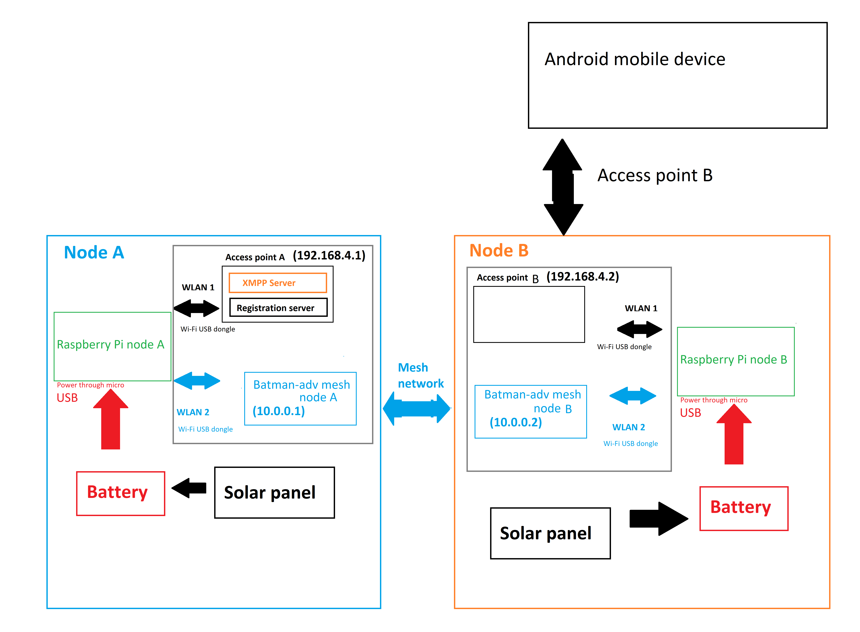

As you can see the registration server and XMPP server are both installed in node A which can be accessed using the same IP address as node A’s local static IP address through WLAN1 interface. The batman-adv mesh network is setup in node A using WLAN2 interface. WLAN1 and WLAN2 are bridged together in order to make registration server and XMPP server accessible from other mesh nodes.

Node B also has batman-adv mesh network setup using WLAN2 interface and Access point setup using WLAN1 interface. Registration server and XMPP server are not installed in this node but we can access registration server and XMPP server in node A through the mesh network by bridging WLAN1 and WLAN2 interfaces in node B. This would let users to access registration server and XMPP server by connecting to node B’s access point. Node B sends the data from node B’s access point (WLAN1) to node B’s mesh node (WLAN1) through WLAN1 to WLAN2 bridge. The data is then sent to node A’s mesh node (WLAN1) through BATMAN mesh network. Finally data is passed to Registration server and XMPP server in node A’s WLAN2 through WLAN1 to WLAN2 bridge in node A.

The mesh networking capabilities are implemented using the open source BATMAN mesh network software. ( https://www.open-mesh.org ). This software takes care of all the implementing the discovery of each node when the system is initiated, the routing to traffic between the nodes and handles re-routing of traffic in case one or more nodes in the network is disabled.

Instructions to setup the software for each mesh node is available here:

https://www.open-mesh.org/projects/batman-adv/wiki

Instruction on how to create the Batman-adv mesh network are explained in step 4 of Appendix A.

To bridge traffic from one USB dongle to the other dongle on the Raspberry PI a bridge needs to be created between two WLAN interfaces. Instruction on how to create access point and Wi-Fi bridge is explained in step 5 of Appendix A.

One of the WiFi dongles will use an omni-directional antenna to provide an access point of users in the locale around the node. The other WiFi dongle will provide the node to node connection between mesh network nodes. The antenna output of that dongle will be connected to a 4 way splitter that distribute the signal to 4 cantenne mounted perpendicular to each other.

Access point is setup using dnsmasq and hostapd packages. Dnsmasq package provides network infrastructure for small networks and hostapd is a package built in Debian OS to create access points as well as support for other drivers, an integrated authentication.

The access points and the mesh network points have static IP addresses assigned to them. As the mesh network is not connected the greater Worldwide Web, it is not necessary to register the IP addresses with an Authority. This save the yearly cost of maintaining the registration of the static IP addresses which introduce a recurring cost to running the system. The static IP addresses can be assigned according to any designation arrived at by the organization deploying the system. The only restriction is that identical IP addresses can not be assign to any other node or server on the network.

Instruction on how to assign the static IP address for each node or server can be seen in step 5.4 of Appendix A.

Message Server Implementation Details

The Message Servers of the system handle all the message traffic of the system. Messages at pushed on to the server by the CEMN App when users send a message. Similarly, the CEMN App pulls messages intended a the user when it send a request to the Message Server to see if any message are available to be read.

The Message Server is also implemented on a Raspberry in order to maintain a consistent hardware microprocessor system component between the nodes and the servers. There is a primary and a secondary Message Server located on the network. The secondary Message Server Acts as a backup if the primary server goes down or is inaccessible due to technical issues with the node that prevent routing message to and from the Message Server.

The CEMN App normally tried to send and receive messages from the primary Message Server. If the CEMN App does not receive an acknowledgement of the receipt of a sent message within 30 minutes (this can be changed by the system administrator) of the original transmission it will re-send the message using the address of the secondary Message Server. After detecting a problem with the primary Message Server the CEMN App will subsequently try to send and pull from first the primary and then the secondary server in 5 minute durations. If the problem is resolved on the primary Message Server (indicated by a message being send and an acknowledgement being receive with 10 minutes) the CEMN App will revert to sending and receiving message from the primary Message Server.

Each Message Server is connected to an individual and separate mesh network node Raspberry PI through the WiFi connection. Messages come into the mesh network node through the mesh network WiFi dongle and then are bridged to the Message Server . The Message Server Raspberry PI also has static IP address.

Similarly pull requests for message come in through the mesh network node WiFi port and routed to the Message Server through the WLAN bridge.

The Message Server is implemented using the open source Extensible Messaging and Presence Protocol (XMPP). The details of the XMPP specification can be seen here:

https://xmpp.org/rfcs/rfc6121.html

XMPP implements almost real-time chat/messaging capabilities between users or entities in the case where the two clients trying to communicate are autonomous devices such in internet of thing device. It provides for a structured method of formatting the packets of the message sent or received by the user client App. XMPP is used by WhatsApp, Yahoo Messenger, Facebook Messenger and early versions of Google Chat. On systems connected to the WorldWide Web that allow access to Trusted Certificate Authorities XMPP also provide secure connections via SSL/TLS. It has limitations in that it introduces extra overhead and the message are formatted in an XML format and the specification does not provide for the acknowledgement of the receipt of messages. XMPP allows for other services to layered on top of its protocols easily so it can be scaled to support other applications. XMPP was chosen for the CEMN design because of the ability to be deployed easily and scale to add extra features and applications.

How to set up a Raspberry PI as an XMPP server is covered here:

https://www.youtube.com/watch?v=sl8cKKwRMKE

It’s also required to select a Host service name when you configure XMPP server which is localhost by default. The selected Host service name should match the Host name in CEMN Chat Android App.

Registration Server Implementation Details

The Registration Server is essentially setup as a phone book for the system. When a new user registers with the system it must send their User Name, Public Key and pass word to the Registration Server. Friend can then look up the new user using their User Name. As the person sending you a message need your Public Key to encrypt a message to use, the Public Key of the new user is added the friend contact list with their User Name when the new user is added to their Contact List on their CEMN App.

The pass word allows the user to change their user name or Public Key on the Registration Server. The pass word is transmitted as an AES-128 encrypted string. The Registration Server decodes the encrypted string pass word and stores the pass word as a Hashed string in a user database stored on the Registration Server. A Hacker gaining access the database will only have access the hashed pass words not the actual pass word.

Every time the Registration Server receives a request update the User Name or Public Key or a request to remove a registration the user must send a valid password encrypted in AES-128 format. The Registration then decode the password and Hashed using SHA-256. The result is then compared to the Hashed value store in the database for the user.

There is a primary and a secondary Registration Server in order to provide redundancy in case the primary system goes down or is made inaccessible due to problems with the nodes surrounding the node that the Registration Server is connected to. The information on the Registration Servers is compared and synced once every 24 hours. If a request sent to the primary Registration Server is not acknowledge with 30 minutes the request is shifted to the secondary Registration Server. If a registration is not found on the primary server, a request is sent to secondary server in case there was a momentary outage that prevented a request from being processed on the primary Registration Server. An acknowledgement is composed of an XML file.

The Registration Server is implemented on a Raspberry PI using a node.js app and mongoDB as database. This was done to maintain a consistent microprocessor component throughout the system. The Registration Server is connected to a mesh network node Raspberry PI through the WLAN. The Registration Server has a static IP address and registration requests are sent to that IP address. CEMN Apps send registration request over the mesh network. The registration requests are received on the WiFi dongle assigned to deal with mesh network traffic for a specific assigned node. Registration request are then bridged to the Registration Server through the WLAN. The Registration Server provides a HTTP Post API for the CEMN Chat app to send messages as raw text which is decrypted using symmetric key and converted to XML format.

There are six type of registration messages the Registration Serve can process:

- Create new user entry
  - Process new username, AES 128 encrypted Password and Public Key
- Retrieve Public Key for User name
  - Process all usernames and Public Key’s and return if the username is available
- Change Username
  - Requires AES -128 encrypted PassWord, old User Name and new User Name
- Change PassWord
  - Requires current AES-128 encrypted current PassWord, Username and AES-128 Encrypted new PassWord
- Change Public Key
  - Requires AES-128 encrypted PassWord, User Name and new Public Key
- Delete User
  - Requires AES -128 encrypted PassWord, and new User Name

The detailed information about the Registration Server and type of registration messages can be explained in Appendix B.

System Privacy and Security Considerations

There are a number of different levels of protection that need to be designed into the system to ensure the privacy of the messages sent through the network.

The fact that the system is isolated geographically means it is difficult to physically get to. Hackers need to be within the proximity of a node in order to get access to the system as the network in not connected to the greater internet and essentially is a local, regional network.

Users are connecting to access points of the mesh network using WP2 encryption so there is a basic level of security for any traffic between the CEMN App and the Message Server and Registration Server. In theory only authorized people from the community with the correct pass word can access the mesh network. This is only a basic level of security though as people often share the pass word when they should not or the encryption is broken.

All traffic is encrypted. Registration traffic and message traffic is encrypted differently. Registration traffic uses a symmetric key that, which is considered weaker than an asymmetric key, is pre-arranged and rotated on a specific schedule. Symmetric key are used as the registration process needs to autonomous.

The XMPP Messaging Protocol technically supports TLS/SSL encrypted sessions, but for that to work the system needs access to a third party Trusted Certificate Authority. The Trusted Certificate Authority is necessary to validate that the website being accessed has been screened and validated to be a legitimate organization. The application the user is using to access a server usually verifies that the TLS/SSL certificated returned by the server with the certificate stored at a Trusted Certificate Authority. Without internet access to the World Wide Web outside of the regional network created by the CEMN it is not possible to access third party Trusted Certificate Authorities. While it is possible to use Self Signed Certificates, essentially digital certificates generated by the organization deploying the network, to enable the TLS/SSL encrypted session the lack of third validation essential makes it an insecure system. A new registered user has not way of knowing if a third party is pretending to by a trusted server.

To get around this the CEMN application uses it own encryption with asymmetric encryption (RSA 2048 for this particular implementation described in this document) being used on the content of the messages being send and received and symmetric encryption(AES-256) being used for the exchange of critical information such as user pass words for the Registration Server. The designers have used RSA-2048 and AES-256 for this design, but an actually implementation would be more secure if the actual encryption methods were changed. Obscuring the actual encryption techniques make it harder for third parties to decode any aspects on the communications. In the interest of making this an open source design the designers have fully disclosed the encryption systems. Though it can be deployed the way the design currently exists, it would be more secure if alternative encryption methods were deployed. Fortunately, the Android Cryptograph library makes it easy to change techniques with minimal effort.

As the registration process is essentially is a one-time event, hackers would have to monitor the system or a long time in order to get access to the encrypted traffic necessary to match the user name to specific traffic. All users are anonymous and only identified by their user name and a public key on the network. The Registration Server never has access to information that explicitly identifies that person such as name, address or another identifier. Message traffic is identified only through public keys.

Authentication Considerations

On the world wide web authentication of service providers came be implemented by using SSL certificates. A trusted authority issues the certificate after validating the user is who he says he is. When a connection is created between a user and a service provider the user’s client App verifies the SSL certificate of the service provider with the third party trusted authority. It is not practical and cost effective to use SSL certificates for this application as there is no access to the internet external to the network designed into the system there is no way to access the certificate authority to verify the certificates.)

Authentication of the service provider is therefore done through the use of encryption of the data being sent. Only properly encrypted data will be interpreted properly by the Registration and Message Servers.

A digital signature is used to verify that the message came from the correct sender.

“A digital signature in its simplest description is a hash (SHA1, MD5, etc.) of the data (file, message, etc.) that is subsequently encrypted with the signer's private key. Since that is something only the signer has (or should have) that is where the trust comes from. EVERYONE has (or should have) access to the signer's public key. So, to validate a digital signature, the recipient (1) calculates a hash of the same data (file, message, etc.), (2) decrypts the digital signature using the sender's PUBLIC key, and (3) compares the 2 hash values. If they match, the signature is considered valid. If they don't match, it either means that a different key was used to sign it, or that the data has been altered (either intentionally or unintentionally).”

Authentication of user is achieved through the registration server via the registration process that makes users register a USER_NAME and a PASS WORD. The user is then assigned an unique ID that identifies them on the Message Server. No specific user has access to the unique ID of another user. Other users are identified through their USER NAME only. As the Registration Server provides validation for a user before the message is broadcast by the Message Server it is difficult for a user to pretend to be another user. This provides authentication and privacy through obscurity.

The ID at least 1024 bits long to make it difficult to cycle though all possible combinations during the short period a message is being transferred.

Data sent to the Registration Server is encrypted so that even if an attacker tried to pretend to the be the Registration Server they would need the encryption keys to decode the data sent to the Registration Server.

“To allow for a method of authentication that is both easier to understand
and easier to use, OTR now includes the Socialist Millionaires' Protocol
(SMP). SMP runs as follows: each user inputs a secret string, say "x"
and "y". They then exchange a series of messages which reveal the value
of (x==y), but no additional information about the inputs. This allows
users to determine whether they hold the same secret information with no
danger of revealing that secret to an attacker.

To see how this is useful for authentication in OTR, assume that Alice
and Bob are chatting over OTR for the first time, though they know each
other well in real life. Alice may send Bob the following message:
"Let's make our shared secret the name of that restaurant we both like
in Ottawa."

Now Alice and Bob run SMP. If Alice is actually talking to Bob directly,
then they will both type in the same restaurant name and SMP will return
success (x==y). However, if an attacker is impersonating Bob or trying
to eavesdrop on the conversation, they will have no idea which restaurant
Alice has in mind, and will type in an incorrect value, causing SMP to
fail. Note that for security reasons, the values compared in the SMP
are actually hashes of several pieces of data, including both parties'
fingerprints, along with their respective secrets. The users, however,
are never exposed to this additional data.

Thus, SMP turns the problem of obtaining an authentic copy of a
fingerprint into the much simpler problem of obtaining any shared secret,
or simply of drawing on shared experiences to generate one.”

Passwords in the database of the Registration Server are Hashed and Salted so that if the database were hacked, the hackers could not easily read all the passwords in the database. Hashing scrambles the passwords entered by the end users and salting adds a string on the passwords to make them longer before they are passed through the hashing function. Hashing is distinct a variation of encryption in that is not intended to be decrypted. The output of the hash function is stored in the password database. When verifying a message, the password sent by the user is in the encrypted message is decrypted and then is passed through the hashing function and then compared with the password in the database.

The detailed description of message encryption and decryption process is showed in Appendix C of this document.

Further Security Issues
Because of the open architecture of the Raspberry PIs the best way to protect the system is to physically isolate the Raspberry PIs (ie pot them in epoxy) used for the Registration Servers so there is no access to the ports.

The CEMN node needs to be installed using another Raspberry PI username instead of the default root username and password to provide some basic security. The SSH and I2C interfaces needs to be disabled using configuration settings once the node is setup.

Long Range WiFi Distribution System

Distribution amplifiers

The goal and purpose of a distribution amplifier is to increase the strength of received signals to a level that is greater than the signal losses associated with the distribution system. To ensure all your devices receive proper strength signals, it’s important that your distribution amplifier be centrally located (relative to distribution lines), since the longer the lines, the more signal loss there will be within the system.

Antenna Design

One of the primary goals in this design is to minimize the need for customized components or advanced fabrication techniques where possible.

A good overview of antennae can be seen in this article:

https://learntomato.com/how-to-increase-wifi-range-with-the-right-wifi-antenna/

The key parameters to consider in selecting an antenna are:

- Direction
- Polarity
- Gain

Antenna designs can be directional or direction-less (which is more commonly known as omni-directional). Omni-directional antenna pick up and transmit the signal of the transceiver in all directions (360 degrees) at the same time. The signal can essentially be thought of as radiating out in the shape of a sphere from the antenna. The small “rubber ducky” antennae that are shaped like a stick and ship with many computer WiFi dongle systems are an example of an omin-directional antennae. As the antenna is radiating the power of the transceiver in all directions in a uniform manner omin-directional antennae tend to have the shortest range for a given power level of the transceiver.

Directional antenna as the name implies directs the power of the transceiver in a specific direction. The power of the transceiver is essentially directed in a cone out from the antenna. The width and shape of the cone is determined by the design of the antenna. The cone can be a tight beam of only a few degrees up to 120 degrees of more depending on the design. Typically, the tighter the cone angle the greater the range as all the power of the transceiver is focus into narrow cone.

The signal being sent out by the antenna can be thought of as a wave. The wave can be horizontal or vertical in orientation. A wave skimming along the surface of the water would be considered a vertical wave and a wave moving at an angle perpendicular would be considered horizontal wave. For an antenna the wave are invisible but they still have a orientation. The orientation of the wave is called the “polarity”. In order for 2 antenna to receive each others signal they must have the same orientation or polarity. If the polarities are perpendicular to each other they will not receive the signal being sent out.

Transmitter can be classified based on their power. As mentioned above the antenna design can focus the power of the signal of the transmitter or spread it out. As a result an antenna can amplify or attenuate the signal from the transmitter. The amount of amplification or attenuation from the antenna is referred to as the “gain”.

Common antenna design for WiFi systems are:

- Omin-directional
- Yagi
- Flat panel
- Parabolic
- Cantenna

Yagi, flat panel, parabolic and cantenna are directional antenna. Flat panel antenna can have a cone angle of between 35 to 120 degrees. Yagi antenna have a coverage of between 12 to 25 degrees. Parabolic antenna bounce the signal off a parabolic shape at the back of the antenna to focus the power in a very narrow beam. Cantennae are unique design that is not a good in terms of gain as the Yagi and parabolic antenna but it is easy to build. As the term directional antenna suggest the antenna have to be aligned in order for the antenna to receive the best signal. If the antenna are misaligned the receiving antenna might receive a weak signal despite all the power the transmitting antenna is putting out. Typically for best reception antenna must be aligned “in line of sight”. Essentially this means you can see the other antenna if you look in the direction the antenna is pointed in. Antenna work best if they are not obstruction between the sending and receiving antenna.

The length of the cable, the types of connectors used, the width of the cable and even the resistance of the cable can introduce losses in power from the transmitter to the antenna or from the antenna to the receiver. Every time you add something between the transceiver elements and the antenna you can expect to affect the amount of power that comes from or to the transceiver from the antenna.

“With outdoor applications and runs over 4 feet long, use low-loss cable such as: LMR-400. If you have a 20 foot run, use 19 feet of LMR-400 for the main line and the smaller LMR-100 cable for a 1 foot pigtail equipped with the connectors you need. Your pigtail may have an N Female on one end, and an RP-SMA Male on the other.”

Most WiFi transceiver system built for computers that support external antenna have an “SMA” connector.

Though not the most effective design in terms of range the cantenna is easy to build from local materials in most part of the world. Cantennas can be build from anything as common as coffee cans to Pringle cans with varying degrees of gain.

“A Cantenna is simply an open-end cylindrical waveguide (waveguide is a hollow metallic tube used to carry high frequency radio waves), constructed from widely available tin cans. The diameter of domestically available cans (which are mostly containers for tinned eatables) supports waveguide propagation at frequencies of order of couple of GHz. Because of its easy construction and optimum operation frequency centered at 2.4 GHz (as used in Wi-Fi wireless networks) it is domestically constructed by armatures for extending range of their wireless connection; sometimes reaching to up to 6-7Km.”

“Cantennas are very inexpensive compared to commercially available Wi-Fi repeater units, but are just as good and some people would argue that they are better.
Because of the stated advantages, they are employed in the following applications around the globe:

The most important application is in Wi-Fi radio range extension.
Rocket’ers use them for high altitude telemetry feedback.
Boaters use them for internet access at their docks and/or while on water.
Military field squads sometimes use Cantennas for carrying wireless backhaul to their bases.”

The instruction on how to build a cantenna can be found here:

https://propakistani.pk/2010/03/19/how-cantenna-works-technically/

The most complete information on the optimum parameters to use for a cantenna are covered in the book “Cantenna the Poor Wifi Hackers Choice” by Sven-Erik Zetterström. The important parameters are the diameter of the tube used to form the antenna, distance of the pickup from the end of the tube and the length of the tube.

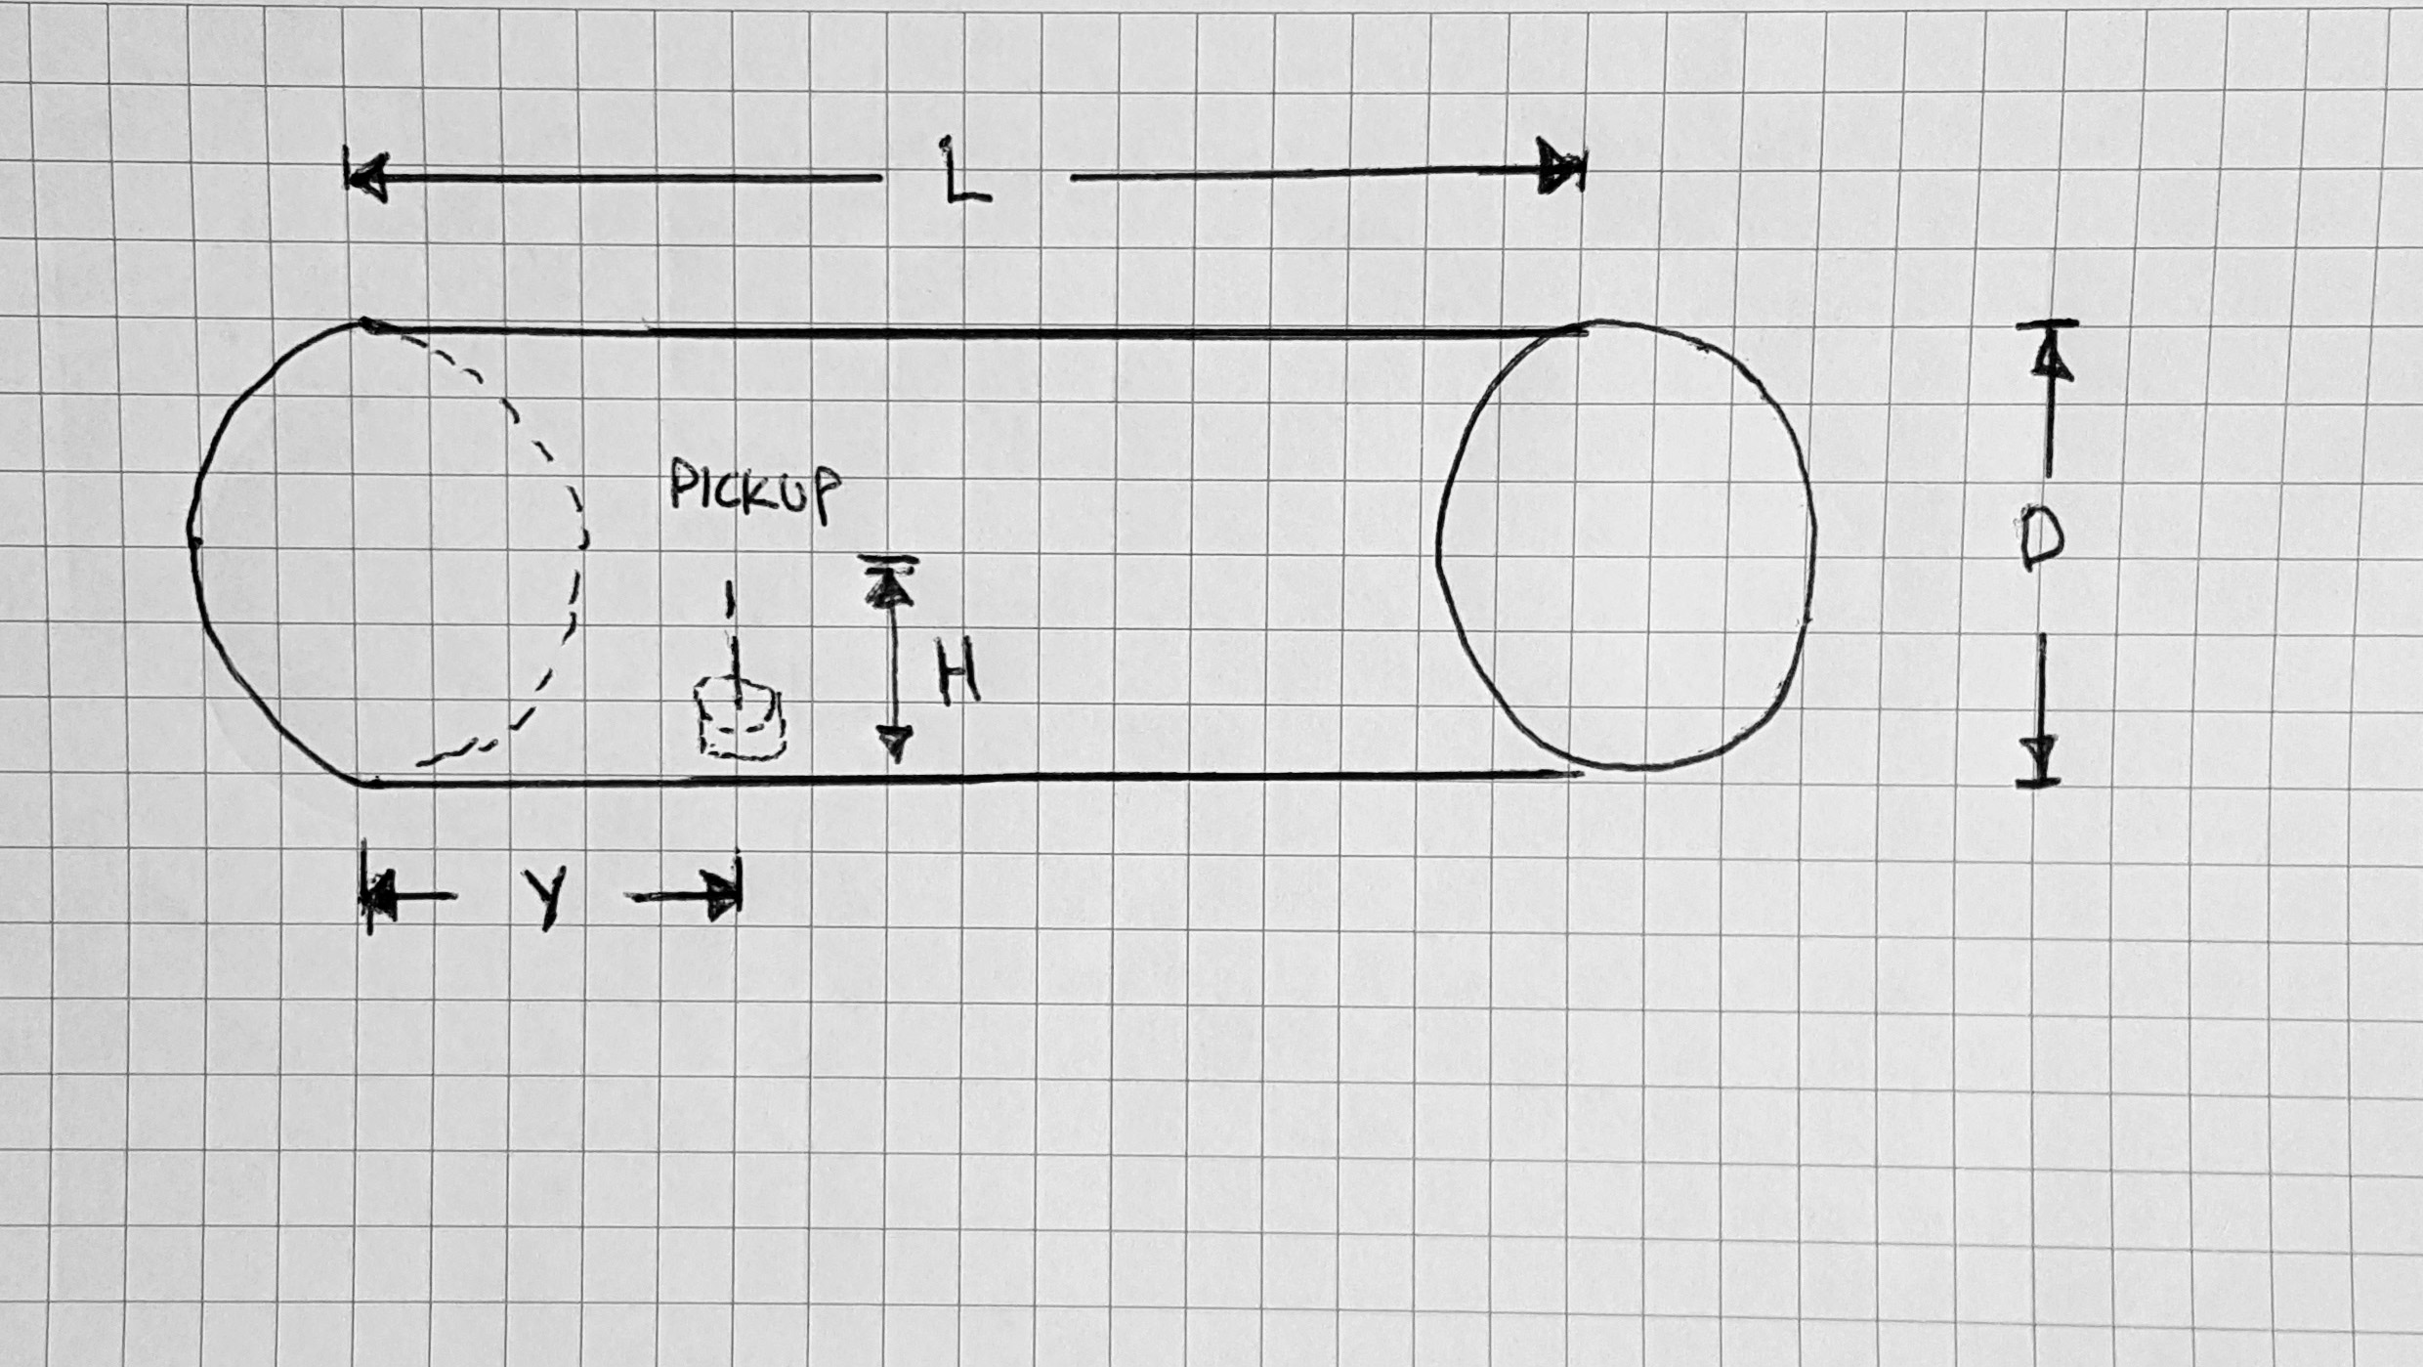

There are a range of values each dimension can be for the cantenna but the approximate starting values are:

•The length of the can, (L) should be longer than 3/4 of the wavelength
•The diameter of the can (D) should be longer than 1/2 of the wavelength
•The copper pickup element should be approximately 1/4 of the wavelength
•The position of the copper pickup element (y) away from the back of the cantenna (rear standoff) is based off the overall diameter of the can and can be calculated using this on-line calculator:

http://web.archive.org/web/20080316034408/http://www.pelaginox.com/pc/pc-cancalc.html

As mentioned above the copper pick up elements should be approximately ¼ of the wavelength of the carrier frequency. WiFi typically has 14 overlapping channels with most WiFi units are shipped set to channel 6. Some Wi-Fi channel numbers overlap with each other. Channel 1 uses the lowest frequency band and each subsequent channel increases the frequency slightly. Therefore, the further apart two channel numbers are, the less the degree of overlap and likelihood of interference. The three Wi-Fi channels 1, 6 and 11 have no frequency overlap with each other for 2.5 GHz WiFi

“Newer 802.11n and 802.11ac Wi-Fi networks also support 5 GHz wireless connections. These frequencies are much less likely to suffer from wireless interference issues in homes the way 2.4 GHz does. Additionally, the 5 GHz Wi-Fi channel choices available in most home network equipment have been pre-selected to choose only the non-overlapping ones.

Choices vary by country, but in the United States these non-overlapping 5 GHz channels are most recommended: 36, 40, 44, 48, 149, 153, 157 and 161.

Usable non-overlapping 5 GHz channels also exist between 48 and 149, specifically 52, 56, 60, 64, 100, 104, 108, 112, 116, 132, and 136. These channels fall into a specially regulated category where a Wi-Fi transmitter is required to detect whether other devices are already transmitting on the same channel and automatically changes its channel to avoid conflict.”

As a run of thumb for 2.54 GHz WiFi cantennae:

“Driven element length never, ever, changes, and is always 31 mm. You will see many instances of online advice that say different; they're wrong. To optimise it for Channel 1, you can make it 0.5 mm longer; to optimise for Channel 11, then 0.5 mm shorter. Otherwise, leave well alone. For practical purposes, it is always left at centre band optimum length, which is around 31mm.”

The current design follow this rule of thumb without issues. Implementations should vary the pickup length depending on the needs for their particular system though. In most rural installation it should not be necessary to experiment too much with pick up height as there should be few devices that should interfere with the system.

Though not the optimum diameter 4 inch heater duct is quite common and comes in 5 foot lengths so that cantenna can be made of a customized length easily with tin snips. Based on a 4 inch diameter for the cantenna the following dimensions apply:

Dimension | Length
Diameter | 4 inches
Length | 5.165 inches
Position of pick from back of cantenna | 1.712 inches
Height of the pick up | 1.22 inches

Though you can get away with a cantenna that is as short as ¾ wave it is suggest that you use at length that is equivalent to two times the ¾ wave length.

The calculations above are for a 2.4 GHz WiFi antenna. The 802.11 workgroup which defines WiFi has documented use in five distinct frequency ranges: 2.4 GHz, 3.6 GHz, 4.9 GHz, 5 GHz, and 5.9 GHz bands. 2.4 GHz and 5.0 GHz are the most common consumer bands. The other bands are reserved for special uses such as vehicle and emergency applications . Each range is divided into a multitude of channels. Countries apply their own regulations to the allowable channels, allowed users and maximum power levels within these frequency ranges. The calculations for the cantenna will therefore vary depending on the frequency band used.

The diagram below shows the assembly diagram for the cantenna.

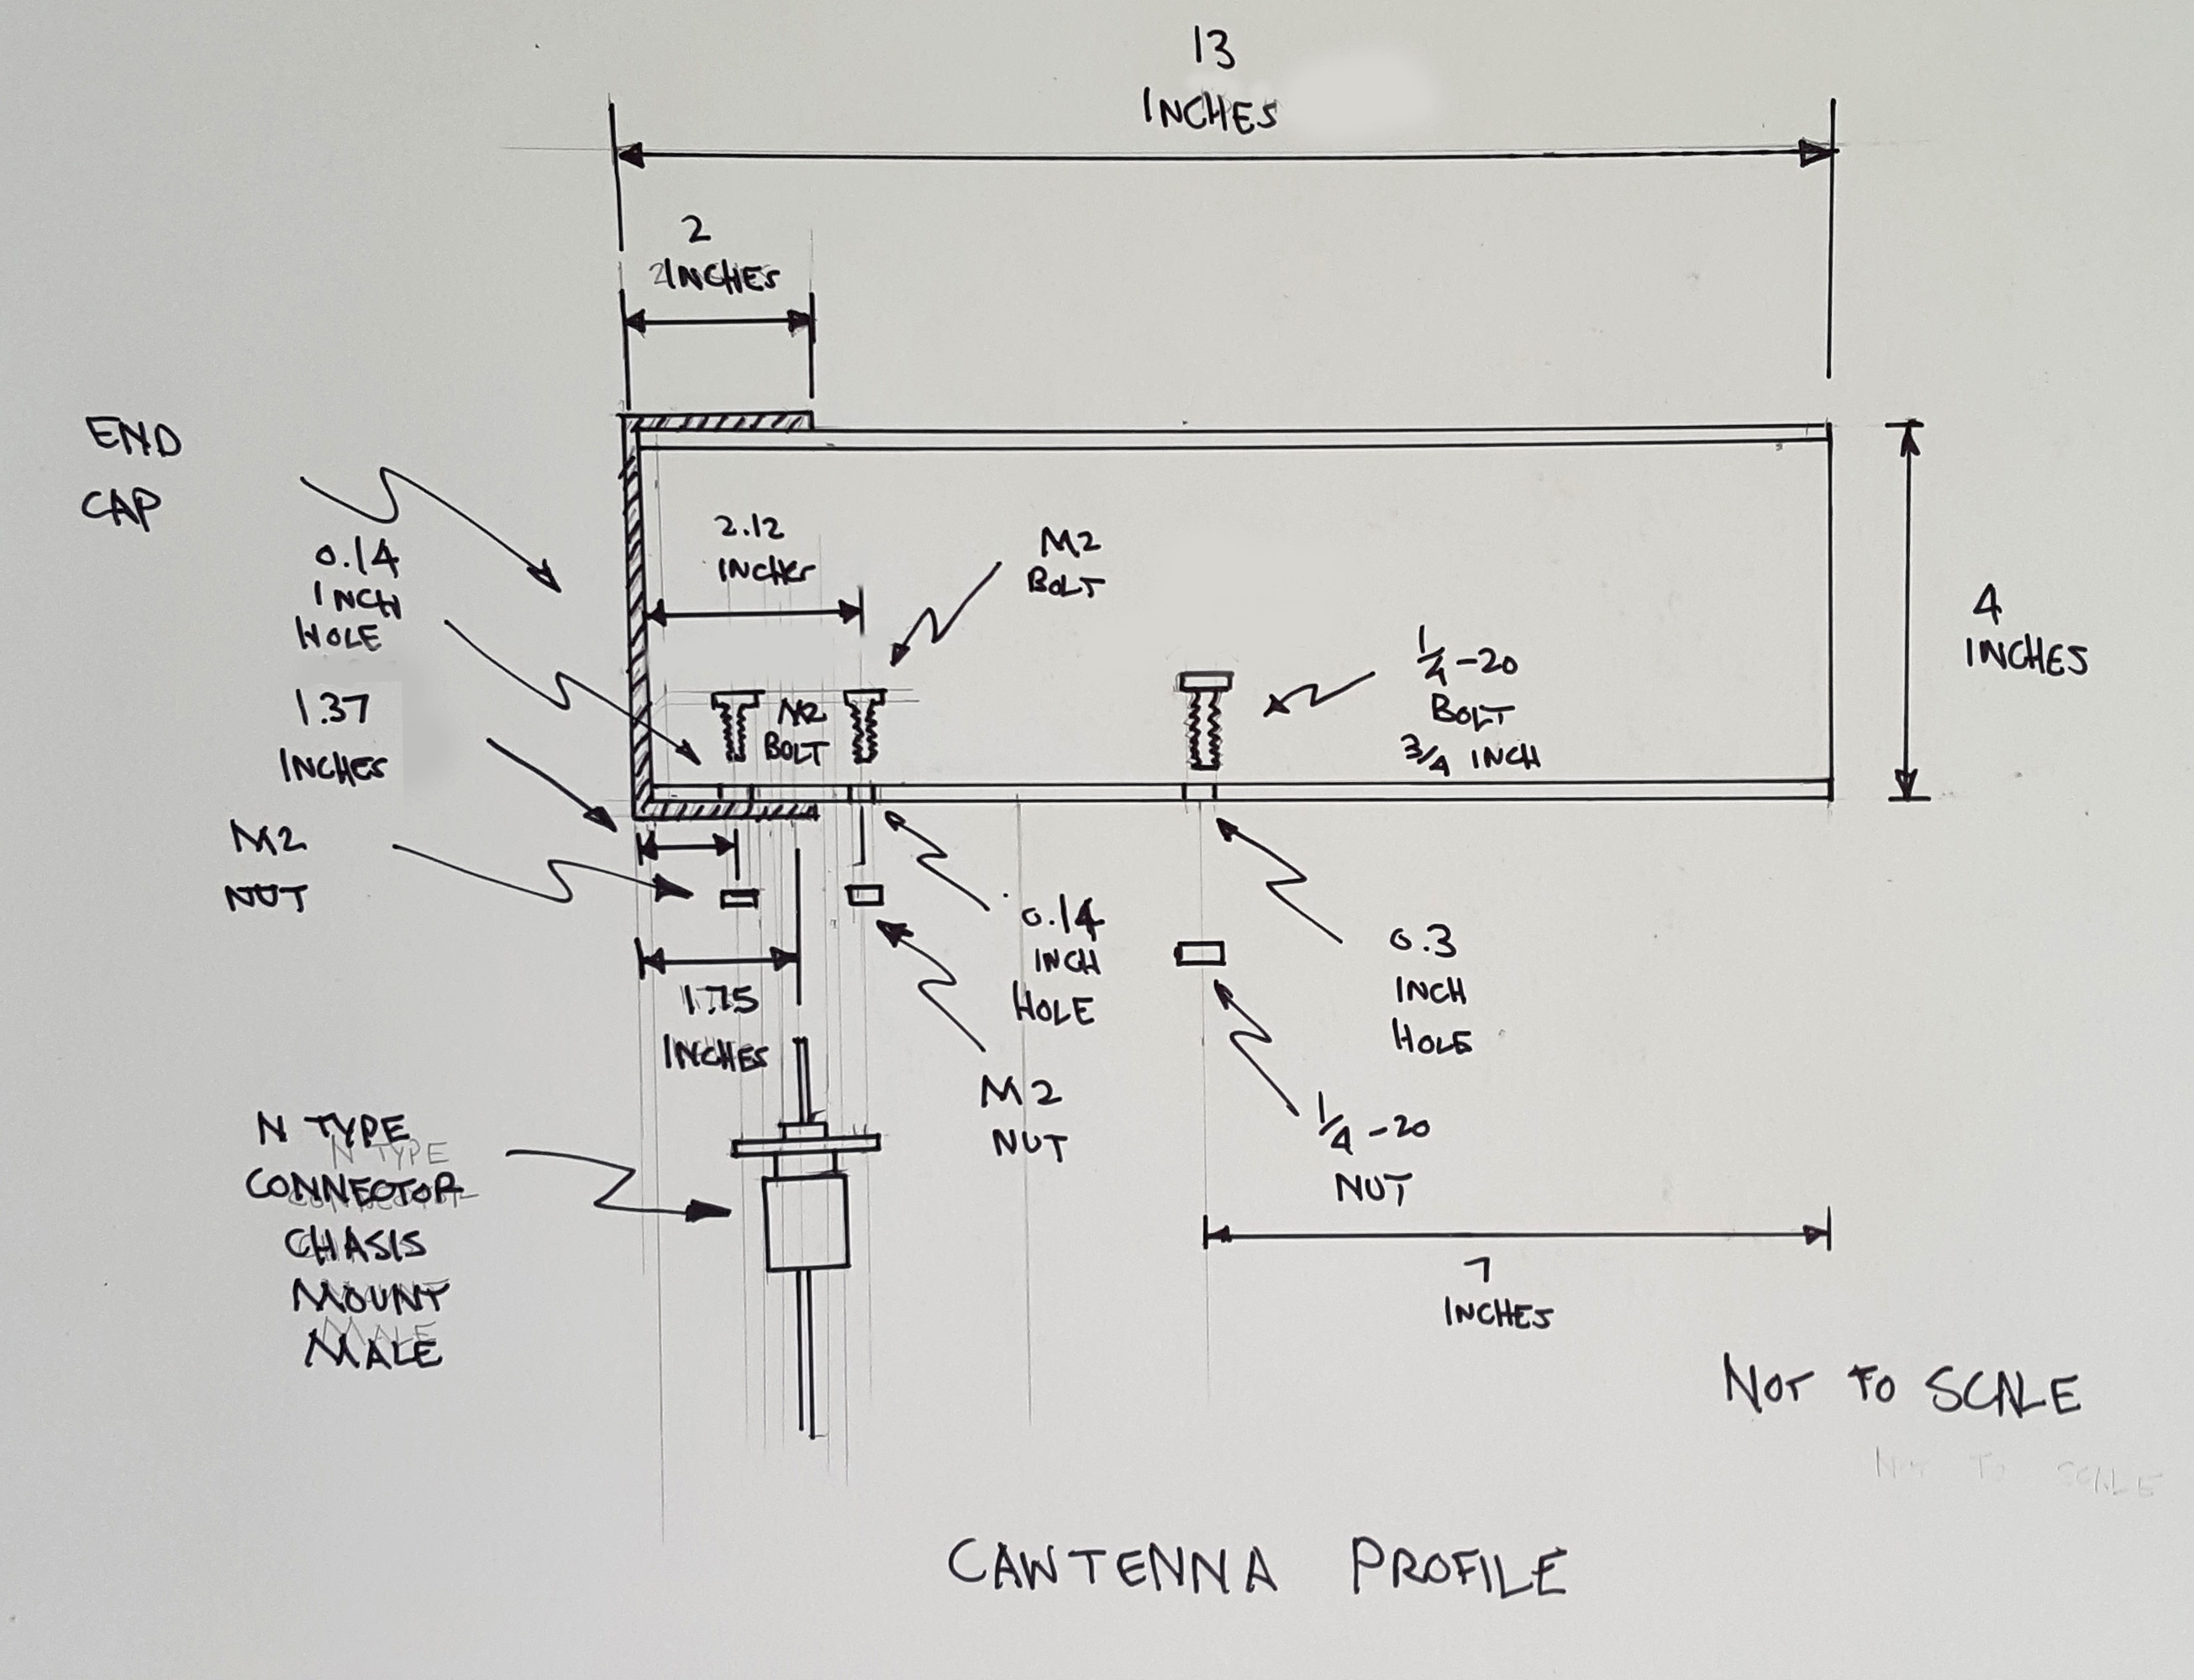

Catenna Profile Diagram

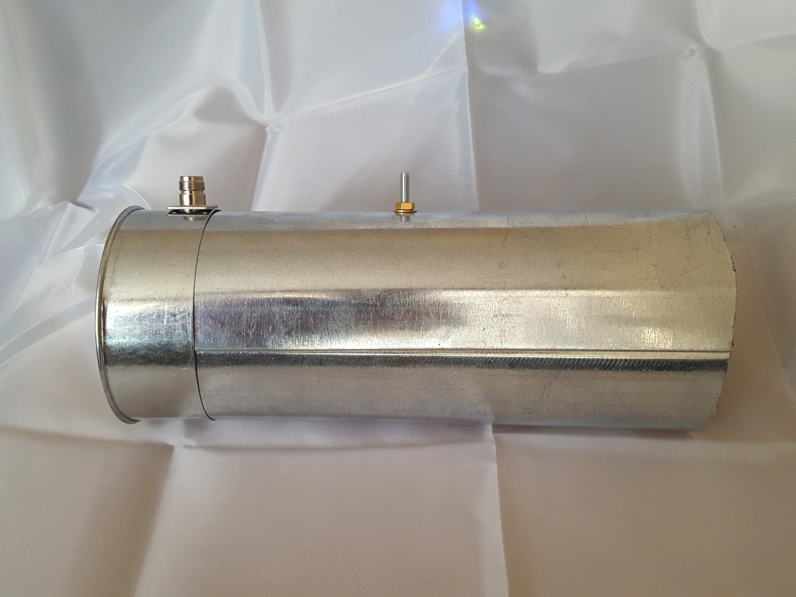

Cantenna with N-type connector and ¼-20 bolt mount

It is made up of:

Item Number # | Part | Number of Parts
1 | 13 inch section of 4 inch heater duct | 1
2 | 4 inch heater duct end cap | 1
3 | Chasis mount Male N-type connector | 1
4 | M2 bolts | 4
5 | M2 nuts | 4
6 | ¼”-20 bolt 1 ¼ long | 1
7 | ¼”-20 nut | 1
8 | 2 flat washers | 2
9 | Male N-type connect to SMA cable | 1

The ¼-20 thread bolt chosen as it fits into a threaded mount that can be attached to a camera tripod for test.

As will be discussed below in the section on the Architecture for the Network Layout, the cantenna can configured as a single antenna for point to point connection between two nodes or a an array when the network is layout in a grid. The assembly diagram below shows 4 cantennae mounted on ½ inch plywood with cantenna point in all four directions so that it can link to other nodes in the grid layout.

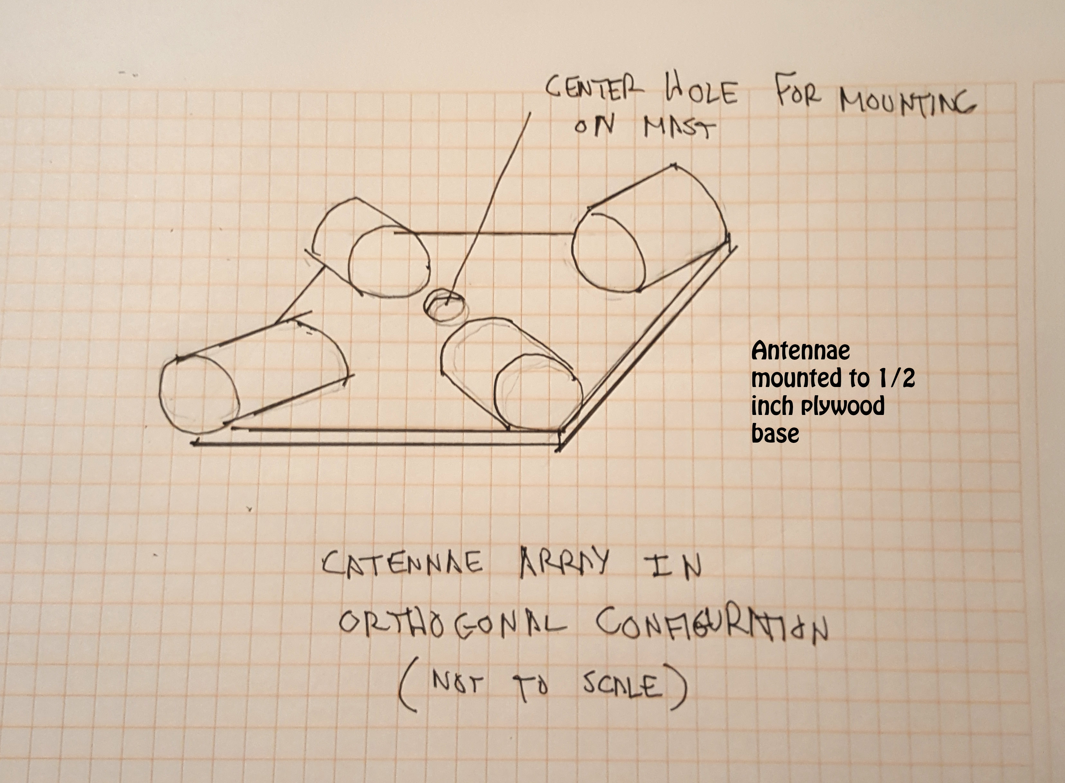
Orthogonal Array of 4 Cantennae

The WiFi signal from the node modules can be split using a 1 to 4 splitter similar to what is shown below. The signal is distributed among the 4 cantennae. Note that the effective range of each antenna is reduced as the power of the signal is divided equally among the 4 antenna. There is an additional 1 dB lost of power due to the splitter. As the effective range is reduce to approximate less than ¼ of the power the range is also reduced. As a result the spacing between nodes is less and greater density per square mile is required. This may or may not be an issues depending on the architecture of the network deployment.

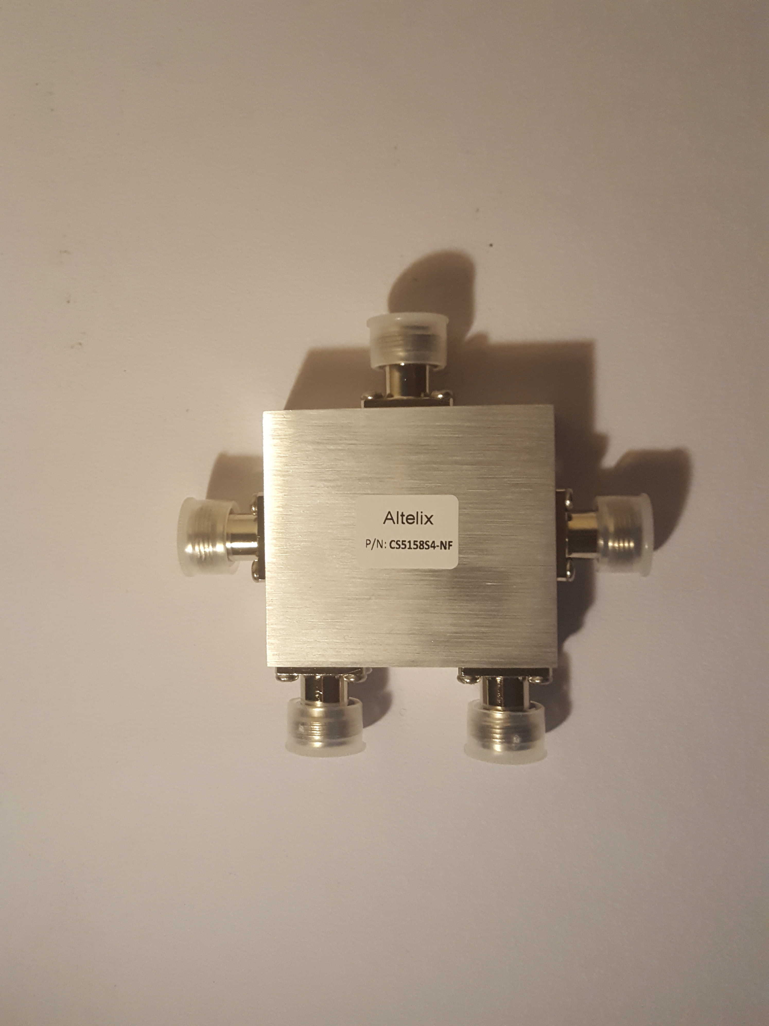
1 to 4 Signal Splitter

If the nodes of the mesh network are laid out in a grid then each node in the mesh network is setup to split the signal of their WiFi transceiver between 4 cantenna so that the can connect to the nodes around them. A four way splitter is used to distribute the signal to the four antenna.

Four way splitters typical have an insertion loss of 6 dB and the signal is then subsequently divided among 4 antennae essentially dividing the power of the transmitter by 4. There will also be a loss where the cable from the splitter connects to the antenna.

Low cost 4 way splitter can be source from Asian suppliers in small quantities:

http://www.alibaba.com/product-detail/4-way-splitter-800-2500mhz_60308104723.html?spm=a2700.7724838.2017115.108.3c93b095OlHUfH

Most common 2 way splitters can be used and connected in series but each stage introduces and additional insertion loss of power.

Each node in the mesh network has 2 WiFi transceivers. One transceiver is setup to route traffic between nodes in the mesh network. The other transceiver is setup to provide an access point to people in the vicinity of the node in the mesh. The access point will typical use an omni-directional antenna. Depending on the power of the transmitter in the access point mobile devices within 10 meters to 30 meters can receive the signal. Depending on the class of the transceiver in the mobile device handset users can expect similar ranges.

The deploying organization can therefore design their system so that users have 24 hour a day, 7 day a week, everywhere access in denser populated areas like a village centre. Placement in those areas would have to be every 30 meters to get seamless, full coverage. Outside of the village centre the density of people per square kilometre might be sparse if it is a rural, agriculture or livestock based economy. As a result the mesh node might be setup more like the phone booth at the general store where users need to travel a ways to get to the nearest node to get service. Node can therefore be spare kilometres apart.

There is not one specific design that will meet the need of every community. The current design is flexible enough that if can be configured to the needs of the community. As main of the components are off the set and no custom boards or advance fabrication techniques are required. The system can be scaled and modified comparative easily.

Power System for the Nodes

Each node is designed to be powered by 5 volts and nominal with 2 or less amps of current depending configuration of the node. Some node will have the mesh network access point and a Registration or Message Server in which case the power requirements will be doubled. Maximum power draw also depends on the amount of system traffic as the transceivers draw more power with they are actively transmitting.

Solar Charging Circuit

The power system needs to provide power to the Raspberry PI and WiFI USB dongles when the node is active during the day and in the evening or on cloudy days when the battery must provide the power. In addition to providing direct power to the system, the solar power system must product sufficient power to also charge the battery.

The charging circuit for the battery is shown below. It is intended for lead acid or Ni-Cd batteries only.

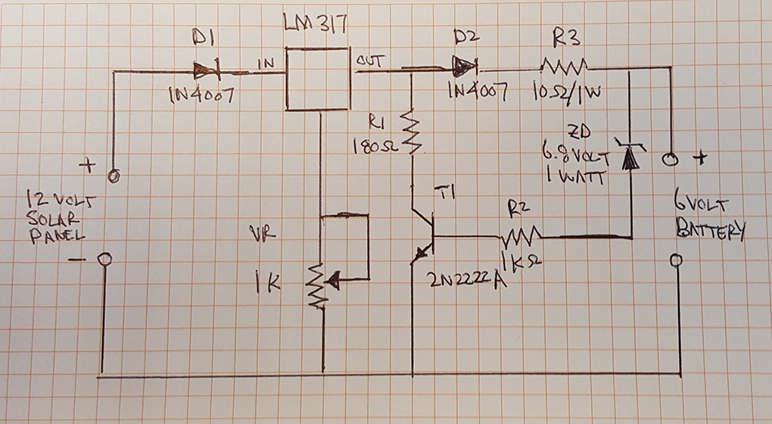

Schematic for Battery Charging System with overcharge protection

Nominally approximately 12 volts is produced by most large solar panels. The current from the solar panel passes through the diode D1 to the voltage regulator, LM317. The output of the voltage regulator is tuned by the variable resistor (potentiometer) VR to set the proper charging voltage for the battery. D1 prevents the solar cell from drawing power from the battery circuit when it is not actively producing current such as at night or on a very cloudy day. When the voltage on the battery reaches greater than 6.8 volts (fully charged battery), the zener diode (zd) break down and turns on the NPN transistor T1 which will then shunt the current to ground through the resistor R1. The goal is to make sure the battery does not get overcharged. Overcharging the battery dramatically reduces the life of the battery as the elevated temperature due to excess current affects the chemicals in the battery.

While a circuit board is available for this design it does not necessary need to be used to implement this design.

http://www.electroschematics.com/wp-content/uploads/2010/01/solar-charger-pcb.rar

In keeping with the overall objectives of this project to keep the manufacturing and assembly local, communities implementing this design have the option to build the solar charing circuit using a prototpye board and connecting wires as the circuit is simple and has a small number of components. This allows a community to add a single or small number of node without having to invest in a product run of boards. Though printed circuit board are more cost effective in general if a large number of nodes are being constructed and installed, it is recognized that communities may want to start with a small number of nodes or add a single node due to limitation imposed by their budget.

The battery charging unit and battery is housed in a box made out of wood, with the holes to pass cable into sealed with silicone or tar. The unit is then sprayed with the same rubberized undercoating used for cars. While 3D printed cases have become very common for low production run products, it is recognized that 3D printers do not exist in any frequency in many underdeveloped parts of the world.

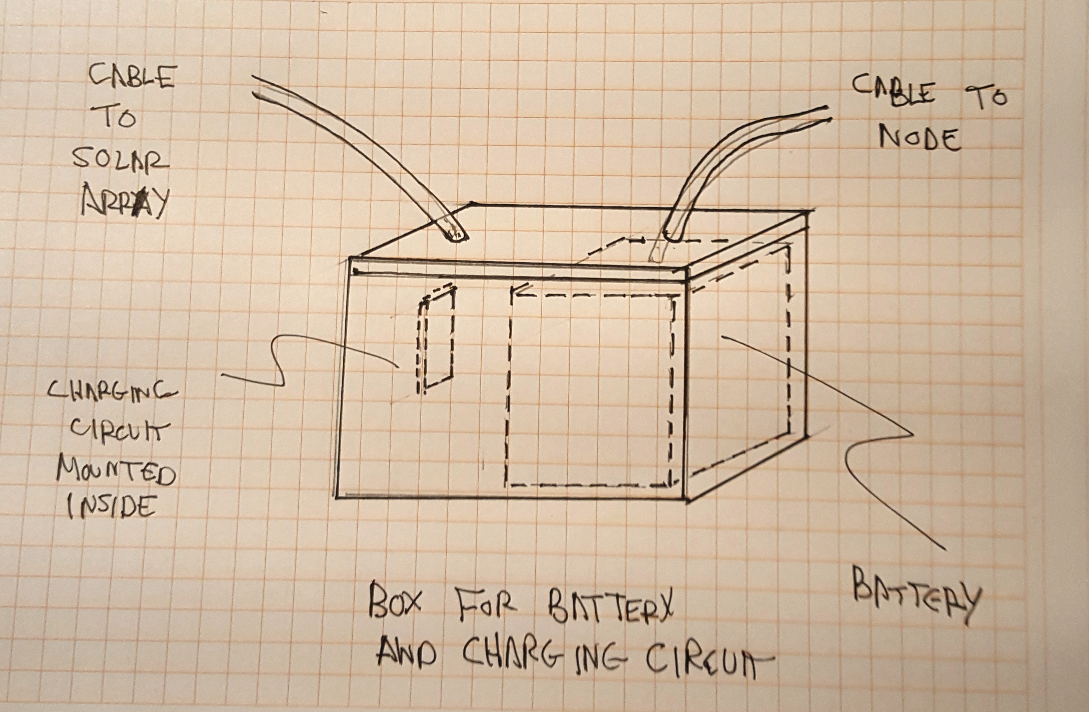
Enclosure for Battery and Charging Circuit

We have not provided specific details of the enclosure as the size of battery really depends in number of hours of usable sunlight are available in the region and the amount of backup capacity that is anticipated to be needed because of the lack of sunlight to charge the battery. This is discussed below. Essentially the enclosure is a box made out of wood and coated with a rubberized spray to protect it. It should be easy to construct locally.

This design used 6 volt batteries as the electronic for the system require 5 volts. But 12 volt batteries could also have been used and the voltage regulated down to 5 volts The overcharge circuit described above would have to modified to accommodate the 12 volt system. The zener diode should be replaced with a 14.3 volt zener diode (volt of a full charged 12 volt battery).

Batteries Capacity Calculation

In regions where it rarely rains the battery capacity of the system only needs to accommodate for running of the system at night when there is no sun to directly power the electronics in each individual nodes. There are essentially two configurations that need to be accommodated:

- the nodes that acts as just an access points and individual node in the mesh network
- the nodes that act as access points, as node in the mesh network and as either a registration server or message server.

The nodes that also contain a registration server or message server have an additional Raspberry Pi installed in the system. Each Raspberry PI draws approximately 400 mA and an additional 1.2 Amp is typical allocated for the draw of any USB peripherals. USB WiFI dongle can draw between 100 mA to 500 mA depending of the design and manufacturer. 500 mA has been used in the calculation to determine the maximum power draw of the system. We will be using 1.5 Amp maximum power draw for the electronics in order to make allowance for additions to the system in the future.

In general lead acid batteries can not be completely drained, once the voltage drops below the equipment’s requirements it will no longer be able to power it. Lead acid battery’s will give you around 50% of their rated power. (i.e. a 10Ah battery has 5Ah of usable power).” Deep cycle batteries need to be selected as they are designed to be discharged slow and re-charged. Car batteries on the other hand are design to to provide a lot of power quickly but it’s not able to cope with a low internal charge and recover fully.

To calculate the amount of battery capacity required and the size of the solar panel the following assumptions are being made:

- the electronics of node with a server incorporated draw 1.5 Amp
- the electronics of nodes with servers incorporate draw 3.0 Amps
- corresponding power requirement per day is therefore:
  - Power = Voltage x current x number of hours of use
    - = 6 volts x 1.5 Amps x 24 hours = 216 watt-hours
    - = 6 volts x 3.0 Amps x 24 hours = 432 watt-hours
- The system must be able to run for 2 days without sun in order to provide extra capacity in the case of cloudy or rainy day where the charge being generated by the solar panel will be non-existent
- 4.2 hours of sunlight is available each day for charging the system (based on the amount of sun in Los Angeles California, the number of hours of sunlight will be longer in tropical regions)
The follow calculator produces the following battery capacity and solar panel requirements:

https://www.altestore.com/store/calculators/off_grid_calculator/

For the nodes without servers as part of the electronics:

- 108 Amp-Hours of capacity are required
- Solar panels of at least 67 watts

For the nodes with servers as part of the electronics:

- 216 Amp-Hours of capacity are required
- Solar panels of at least 134 watts

Note that the calculation assume only a 50% discharge to your batteries to optimize battery life.

Potential choice for the batteries are the Deka Solar Flooded Wet Cell Battery 6V 370 AH, LTP Terminal 8L16LTP deep cycle lead acid batteries. As with any high capacity battery the weight is an issue coming in at 113 pounds. Comparable Lithium ion batteries are only slight lighter (93 pounds) , cost 10 times as much and require more complex charging circuitry.

Usage patterns will ultimately determine how much battery capacity is actually required. It needs to recognized that access to power to charge phones of users are not necessarily readily available in most communities so the heavy usage patterns seen in developing countries is not seen in under developed countries.

Solar Panel Selection for the System

As shown in the calculations above solar panels with at least 67 watts of capacity are required for the basic node access point and at least 134 watts is required for nodes with the servers installed. As with all the pricing in this project we have sourced from American suppliers know that it is possible to achieve lower pricing from Asian suppliers. The exact pricing typical depends on the volume of each part ordered. Not knowing the specific quantity required for a specific application we are making the assumption that the lowest American prices will be the high end of the range when the equivalent part is source from an Asian supplier. We do know that shipping from America suppliers can be expensive relative to the cost of the parts in some cases. In an actual implementation the final price will depend on the price achieved from Asian suppliers. There are some historical international treaties that provide low price shipping to specific regions of the world.

A typical low cost unit is this 100 watt solar kit for $145.

https://www.harborfreight.com/100-watt-solar-panel-kit-63585.html

Lower pricing can be achieve when ordering from Asia suppliers:

https://www.alibaba.com/product-detail/2015-hot-sale-in-Africa-most_60243891407.html?spm=a2700.7724838.2017115.73.6152e033oFBCbq

Lightning Strike Protection

In some parts of the world lightning strikes are a real hazard. To protect the equipment it is recommended that lightning arrestors be installed. The lightning arrestor are install in line with the antenna cable. When the voltage exceeds the discharge voltage, the surge suppressor instantly dumps the voltage safely to ground. They can withstand multiple lightning strikes.
For simplicity, inline lightning arrestor are recommended in this design.

A typical lighting arrestor is available from a supplier like RadioLabs:

N-Male x N-Female Inline Mount

The arrestor can introduce a 0.4db Max Insertion Loss and has a breakdown voltage of 350V or 90V. Typical single unit pricing is $29.

Packaging of Each Node in the Mesh Network

While 3D printing has made packaging of hardware designs more cost effective for small production run products, 3D printers still does not exist in any frequency in many under developed countries. Rather than develop complex 3D models, the designers recognized there are many local artisans that are skilled at working in wood and depending on the country wood can be more accessible as a raw material than refined plastic filament. The housing of electronic modules for an individual node in the mesh network is therefore fabricated out of wood and the individual pieces nailed or screwed together. The opening use to pass cables through to connect to the antenna and the power system are seal with silicon or tar with make them water proof. The complete enclose is then painted or sprayed with the same rubberized material used to coat the undersides of cars to prevent them from developing nicks from pebbles and rusting. The plans for the housing is shown below. The electronic modules are mounted on ¼ inch plywood to make for easier assembly. The ¼ plywood sheet with electronics are then enclosed in a box made out of ½ inch plywood. Plywood has been used for the design but any local wood can be substituted. Refer to Appendix C for sketches of the plans and assembly drawings.

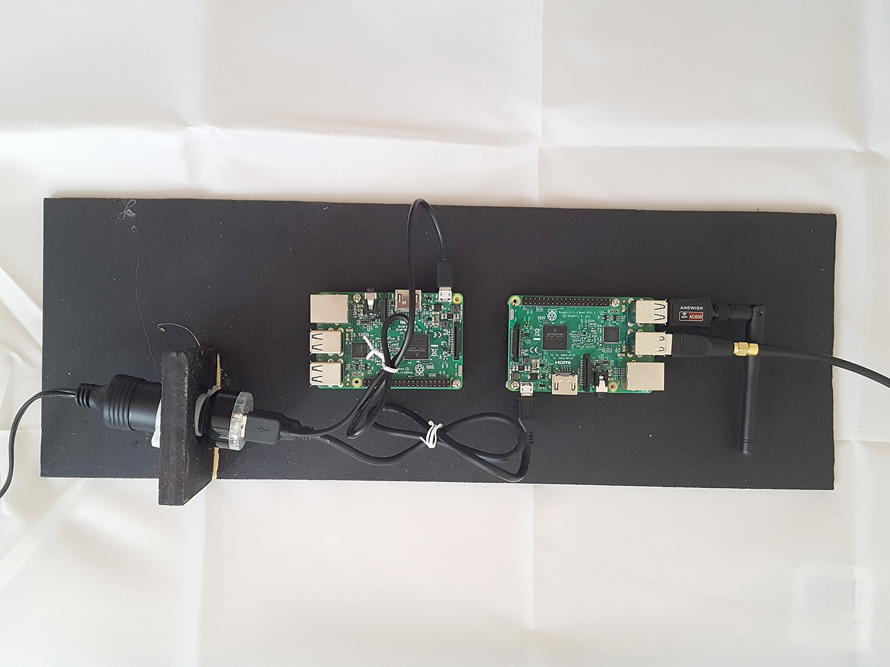

Electronic and power system mounted to base insert for enclosure

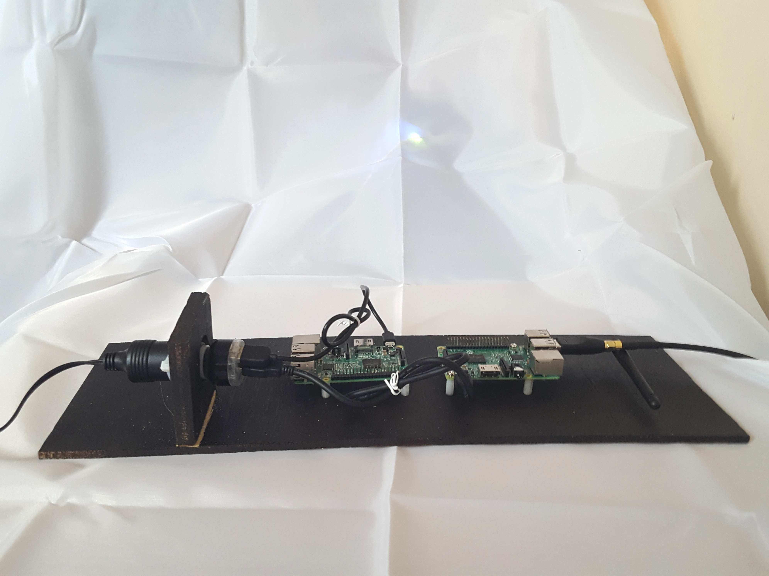

Side view of electronics and power system mounted on base insert

Architecture for the Network Layout

When we thing of the coverage of networks in dense urban setting in developed countries we think of ubiquitous, 24 hour a day, seven day a week access to the network. We forget there was a time when people went to the corner drug store to make a phone call because they could not afford to have a telephone in their house. In the same way the Community Engagement Mesh Network can be set up to be a dense network where everyone gets coverage 24 hours a day and seven days a week or the network can be set up to be a series of regional access points where you need to travel to the local hotspot in order to use the network.

Most mobile phones have a WiFi transceivers in them that typical have a range of 10 to 30 meters (class 1 transceivers). As a result to have always on ubiquitous access to the system the nodes in the mesh network can be placed at the most 20 to 60 meters apart. Nominally the placement will be closer together in order to prevent “dead zones”, spots where there is no or weak coverage. The WiFi Access Transceiver of a mesh node is designed to have an omni-directional antenna. An omni-directional attennae has a spherical range of coverage. The spherical regions need to overlap to reduce the size of any potential dead zone where the signal is weak or not sufficient to be usable.

Increased density requires increases cost as more nodes need to be deployed. A compromise is the have a denser network near the densely populated parts of a community such as the village or town center and local access points where people have to travel to use the service in the further out rural parts of the community. Single cantanne configurations of the design in this system have a tested ranges of up to ¾ mile, properly align parabolic antenna have even longer ranges of many miles provided there is a clear line of sight between antenna. It is important to know how the WiFi protocol acknowledges each received frame. If the acknowledgement is not received, the frame is re-transmitted. By default, the maximum distance between transmitter and receiver is 1.6 km (1 mi). On longer distances the delay will force retransmissions. While it is possible to modify the WiFi protocol to get around this limitation the objective of the designers were to try to stick to off the shelf modules that can be easily assembled locally without extensive modifications. Since this design uses USB WiFi dongle, to get around the limitation of commercially available WiFi would require the design of custom hardware which would requiring regulatory testing. The advantage of using commercial available modules if that they can easily be imported and setup without additional regulatory approvals.

The layout of the nodes also affect the design of the antenna array attached to each node in the mesh network. A grid layout of the network means the each antenna array can have 4 directional cantennae configured perpendicular to each other so that each node have access to the 4 adjecent nodes to it in the grid pattern. Different network layout require different antenna array designs. As mention above if the signal is split then the effective range is reduced as the power of the signal is evenly distribute to each antenna. While power amplifiers are available to amplify the signal they also need to be powered by the system and they can cost as much as all the other components and modules in an mesh node access point.

The overall network layout for a community needs to be customized to the needs of the particular community. The available budget, the density of the neighbourhoods in the community and the topology of the local terrain all have an effect on how the network architecture needs to be designed.

Connecting the Mesh Network to the Outside World

Though this system was designed to run as an isolated, independent network it is possible to connect it to existing infrastructure. Modem cards exist that can be used to connect one or more of the nodes to an existing GSM or LTE network. GSM modems card are more common and more affordable as the technology is mature. Ironically many developing countries are skipping GSM deployment and going right to the more advance and up to date LTE cellular technologies. Those countries with GSM are slowly phasing them out. There is currently only one LTE modem available on the market and it is quite expensive in comparison to the electronics of a single node. A more affordable unit is coming out but will not be available to November of 2018.

As a result of the lack of an affordable LTE modem card with more than one supplier, the implementation of a connection to an existing cellular network is left as a theoretical exercise for now. Information on the way other users have implemented GSM network connection with Raspberry PI’s can provide insight into the implementation approaches and challenges. Some of the relevant articles are:

Cost Comparison

Ultimately this goal of this project was not about the technology but about creating a cost effective method of providing communication services to regions of the world that currently do not have the service or are underserved due to the cost of the service.

The average cost of constructing a cellphone tower in a developed country is between $100,000 to $350,000 for each tower.

A typical breakdown of the cost are:

“Cell tower costs vary widely, depending on what kinds of deals the constructor has with various vendors. Generally, constructing a tower costs around $200,000 or $250,000. About $150,000 of that is for "civil installation" which includes pouring concrete, the mast and its erection, backup generators, fencing, tiny air-conditioned shack, and security systems. The telecommunications guts (baseband processors, transceivers, power supplies, amplifiers, etc) will run a minimum of $20,000 to $50,000 for the equipment -- and another $25,000 for installation ($75,000 for equipment and installation). There may also be about $5000 worth of costs to connect the tower to the core network, depending on its location and infrastructure.”

There were 2009 prices so they may be more or less depending on part of the world you are in. The price comparison will not focus on the “civil installation” cost as they will vary by the region the installation is being made in. In addition so the requirement for the WiFi nodes are not similar to the cellphone towers. The height of the towers can be lower as the spacing between WiFi towers need to be less than 1 mile or the acknowledgement of the reception of the packets and a transmission will time out. The size and weight of the electronic equipment and the power requirements are significantly less. Also the physical security requirements will be different as no physical generator are being used and the power generation equipment is significant less in dimension and weight though the value in being able to generate useful power is similarly attractive for vandals.

“Cell phone traffic through a single site is limited by the base station's capacity; there is a finite number of calls or data traffic that a base station can handle at once. This limitation is another factor affecting the spacing of cell mast sites. In suburban areas, masts are commonly spaced 1–2 miles (2–3 km) apart and in dense urban areas, masts may be as close as ¼-½ mile (400–800 m) apart.”

The actual maximum distance between a cellphone and a tower depends on the technology (GSM, CDMA, LTE).

“As a rough guide, based on a tall mast and flat terrain, it is possible to get between 50 and 70 km (30–45 miles). When the terrain is hilly, the maximum distance can vary from as little as 5 kilometres (3.1 mi) to 8 kilometres (5.0 mi).”

Depending on the the conditions omni-directional antenna using typical consumer WiFi systems get between 30 meters to 100 meters of range depending on the design of the handset. Most consumer WiFi dongles and routers are limited to 100 milliwatts of power. Typically most handsets use less powerful class 1 transceivers but we will use the 100 meter range for the assumptions in this section. At approximately $750 costs per node it would require 100 nodes to provide coverage for 1 square mile of area or given 1.6 kilometer per mile 256 nodes for a square mile. Given the cost per node of approximate $750 the cost to cover a square mile is about $192,000. Keep in mind the $750 cost is a worst case scenario using single unit pricing. That amount is approximately comparable with the cost of $150,000 to $250,000 mentioned above for towers in dense suburban centers where the spacing is approximately 1 mile apart.

For the same level of service it looks like the costs are comparable.
The value proposition for the CEMN really has to do the lower recurring cost to users of the network as they own the network. If a community does not need ubiquitous, always on coverage everywhere they can deploy smaller areas of higher node density and link them with areas of lower node density to get more coverage at a more cost effective way. The spacing between nodes can be as much of 1 miles and with proper alignment those numbers have been achieved. Since the community can deploy capacity as needed there is not the need to make the investment of a single tower all at once. The “corner drug store” approach where you travel to a nearby node spaced further apart may be more economically viable and bring the cost per square mile down significantly. By controlling the infrastructure they also can control their access to information which may be the more important outcome. Spacing nodes 1 mile apart brings the price down to $3,000 per square mile. In addition communities where building commercial infrastructure is not commercial viable they can deploy their own networks and link with a distance network so that they can receive and send text message information outside of their region when necessary while improving the dialog within their regional community.

Summary

With any technology project is possible to get lost in the “coolness” of the technology. This project did not use the most recent technology to get the smallest and lowest power consumption design. It did not use the cutting-edge design techniques to try to push the technology to the edge. Rather this project focussed on delivering a very specific and badly needed service to unserved regions of the world taking into consideration the economic, social and political characteristics of those regions. The design used as much existing tried and test open source technology as possible to achieve the performance requirements set out at the beginning of the project.

What started as a paper design in the first round of the HackADay prize to connect people in developing countries using either Peer-To-Peer networks on handsets augmented with a wireless mesh network has evolved to a refined design that tries to address some on the realities in the communities of under developed countries: limit budgets for infrastructure, lack of access to advanced manufacturing techniques, lack of free exchange of information and a lack of trusted sources of information.

The CEMN is design to be secure (encrypted) and authenticated messaging system that can be deployed cost effective in undeveloped and disadvantaged regions. It is made up of off the shelf modules so it can be assembled locally. As many sub-systems as possible tried to use potentially available local materials so the construction could be done locally.

Text messaging is the most cost effective means of getting information out in developing countries by government and non-government organizations. Because of the cost of sending text messages by individuals it is often a one way conversation. CEMN provides a way for people in developing countries to have a two way conversation by having the community own the network.

The design used off the shelf hardware component modules so that the design could be a plug and play as possible. It relied heavily on open source software to implement the features such a fault tolerance of the mesh network and message server software to handle messaging. Being able to freely exchange, trusted information is something we take for granted in developed nations. In some countries it is against regulations to import any technology that encrypts communications, so the designer chose not to use some of the open source encryption schemes and software add-ons. In addition as the network could be potentially be closed with no connection to the great World Wide Web, due to their being no third party infrastructure in the region, the use of trusted third party sources to validate hosts are problematic and many of those open source encryption schemes depended heavily on third party sources to create secure connections. The designer decided on a more simplistic scheme to encrypt the messages and to provide validation. The encryption can be implemented after the fact without importing an explicit encryption technology into a country. The encryption schemes were chosen to not be overly elaborate, so programmer without encryption and security experience could implement them, but effective enough as to be considered secure.

The challenge of this project was to create a system that could be deployed affordably, be maintained by people with no advance technical training, be fault tolerant as it may be months before trained staff can be in a remote region and be self powering in the absence of centralized power sources. Fault tolerance is a key important element in an environment where ownership of the infrastructure by the locals is not guaranteed. As a result regular servicing is not always done. There are countless examples where clean water infrastructure has been left to fall apart due to the lack of regular care.

This was not a project about creating the newest and the greatest technology. It was a project that tried to understand the cultural and economic realities of the end users and then create a solution that provided real world services that are needed and desired to its end users.

Changing the world 117 characters at a time.

Appendix A: Setup Instructions

- Download and install the necessary packages
  - Install the necessary packages ( All nodes )
sudo apt-get update
sudo apt-get install git
sudo apt-get install iw
sudo apt install libnl-3-dev libnl-genl-3-dev
sudo apt-get install -y bridge-utils hostapd dnsmasq batctl

  - Download the source code from github
git clone https://github.com/Arznix/CEMN-Chat-Mesh-Network.git

- Download and install the Registration server node (Registration node)
  - Install Mongodb
    - Install mongodb
sudo apt-get install mongodb-server
    - Start it as a service when the raspberry pi starts
sudo service mongodb start
  - Install nodejs and npm
    - Download nodejs
wget https://nodejs.org/dist/latest-v6.x/node-v6.11.4-linux-armv7l.tar.gz
tar -xvzf node-v6.11.4-linux-armv7l.tar.gz
sudo mv node-v6.11.4-linux-armv7l /opt/node
sudo mkdir /opt/bin
sudo ln -s /opt/node/bin/* /opt/bin/
    - Add the binaries in the PATH
sudo nano /etc/profile
PATH="/usr/local/sbin:/usr/local/bin:/usr/sbin:/usr/bin:/sbin:/bin:/opt/bin"
    - Check that everything is okay by taping these commands:
npm --version
node -v

  - Setup Registration server and add it as a service
    - Install Registration server packages
cd ~/CEMN-Chat-Mesh-Network/Registration-Server
npm install
    - Test Registration server
node server.js
    - Add cemn_registration.sh startup scripts to init.d as a service
sudo cp /home/pi/CEMN-Chat-Mesh-Network/Registration-Server/cemn_registration.sh /etc/init.d/cemn_registration
    - Next, we’ll need to make the cemn_registration executable.
sudo chmod 755 /etc/init.d/cemn_registration
    - Add cemn_registration service to startup services.
sudo update-rc.d cemn_registration defaults
    - Check if service is running
sudo service --status-all

- Install and configure XMPP if it's XMPP server node ( XMPP node )
sudo apt-get install ejabberd
sudo dpkg-reconfigure ejabberd
Note: Select localhost as default service name

- Setup batman-adv mesh network ( All nodes )
  - Make sure both USB Wifi cards are running using iw dev command. We use wlan2 to setup batman-adv mesh network and wlan0 to setup Wi-Fi access point since we are using an external USB Wi-fi card to setup mesh network and the Raspberry pi 3 internal Wifi chip to setup access point.
iw dev
  - Update the wlan number in cemn_mesh.sh located in Mesh-Network directory. It will be the wlan you selected in previous step to setup batman-adv mesh.
cd ~/CEMN-Chat-Mesh-Network/Mesh-Network
sudo nano cemn_mesh.sh

Content of cemn_mesh.sh:
#!/bin/bash

### BEGIN INIT INFO
# Provides: cemn_mesh
# Required-Start: dbus
# Required-Stop: dbus
# Should-Start: $syslog
# Should-Stop: $syslog
# Default-Start: 2 3 4 5
# Default-Stop: 0 1 6
# Short-Description: CEMN mesh server
# Description: CEMN Mesh server
### END INIT INFO

# Activate batman-adv
sudo modprobe batman-adv
# Disable and configure wlan2
sudo ip link set wlan2 down
sudo ifconfig wlan2 mtu 1532
sudo iwconfig wlan2 mode ad-hoc
sudo iwconfig wlan2 essid cemn-mesh-network
sudo iwconfig wlan2 ap 02:12:34:56:78:90
sudo iwconfig wlan2 channel 3
sleep 1s
sudo ip link set wlan2 up
sleep 1s
sudo batctl if add wlan2
sleep 1s
sudo batctl ap_isolation 1
sleep 1s
sudo brctl addif br0 bat0
sleep 1s
sudo ifconfig wlan2 up
sudo ifconfig bat0 up
sleep 5s
# Use different IPv4 addresses for each device
#sudo ifconfig bat0 172.27.0.xxx/16

  - Add cemn_mesh.sh startup scripts to init.d as a service
sudo cp /home/pi/CEMN-Chat-Mesh-Network/Mesh-Network/cemn_mesh.sh /etc/init.d/cemn_mesh
  - Next, we’ll need to make the cemn_mesh executable.
sudo chmod 755 /etc/init.d/cemn_mesh
  - Add cemn_mesh service to startup services.
sudo update-rc.d cemn_mesh defaults
  - Comment out the unused script in /etc/rc.local
  - Remove psk and ssid from wpa_supplicant.conf
sudo nano /etc/wpa_supplicant/wpa_supplicant.conf
- Setup Access point and bridge ( All nodes )
  - Edit line #20 in /lib/udev/rules.d/75-persistent-net-generator.rule file and add "wlan*|"
sudo nano /lib/udev/rules.d/75-persistent-net-generator.rule
Note: This will generate /etc/udev/rules.d/70-persistent-net.rules file
  - Reboot the node
sudo reboot
  - Check the wifi chips have correct wlan interface
sudo nano /etc/udev/rules.d/70-persistent-net.rules

Note: We are using another USB Wifi card to setup Wi-Fi access point in Raspberry pi 3. so, We will be using wlan0.

  - Configure a static IP for wlan0 by opening up the interface configuration file with following command:
sudo nano /etc/network/interfaces

allow-hotplug wlan0
iface wlan2 inet static
address 10.0.0.xxx
netmask 255.255.255.0

auto br0
iface br0 inet static
address 192.168.4.xxx
netmask 255.255.255.0
bridge_ports bat0 wlan0
bridge_stp off

iface default inet dhcp

For example: The address for first node will be 10.0.0.1

  - Restart dhcpcd
sudo service dhcpcd restart
  - Reload the configuration for wlan0 with following command
sudo ifdown wlan0; sudo ifup wlan0
  - Create a new configuration file and add Access point configuration settings to it
sudo nano /etc/hostapd/hostapd.conf

Content of /etc/hostapd/hostapd.conf:

# This is the name of the WiFi interface we configured above
interface=wlan0
# This is the name of the bridge interface which is used if you are bridging mesh network and access point
bridge=br0
# Use the nl80211 driver with the brcmfmac driver
driver=nl80211
# This is the control interface
ctrl_interface=/var/run/hostapd
ctrl_interface_group=0
# This is the name of the AP and should be different for each node
ssid=CEMN-AP1
# Use the 2.4GHz band
hw_mode=g
# Use channel 6
channel=6
# Enable 802.11n
ieee80211n=1
# Enable WMM
wmm_enabled=1
# Enable isolation mode
ap_isolate=1
# Accept all MAC addresses
macaddr_acl=0
# Use WPA authentication
auth_algs=1
# Require clients to know the network name
ignore_broadcast_ssid=0
# Use WPA2
wpa=2
# Use a pre-shared key
wpa_key_mgmt=WPA-PSK
# The network passphrase
wpa_passphrase=cemnberry
# Use AES, instead of TKIP
rsn_pairwise=CCMP
beacon_int=100
ieee80211n=1

  - Check if it's working at this stage by running following command:
sudo /usr/sbin/hostapd /etc/hostapd/hostapd.conf

You should get something similar to following message:

"Configuration file: /etc/hostapd/hostapd.conf
Failed to create interface mon.wlan2: -95 (Operation not supported)
wlan2: Could not connect to kernel driver
Using interface wlan0 with hwaddr b8:27:eb:69:f2:10 and ssid "CEMN-AP1"
random: Only 18/20 bytes of strong random data available from /dev/random
random: Not enough entropy pool available for secure operations
WPA: Not enough entropy in random pool for secure operations - update keys later when the first station connects
wlan0: interface state UNINITIALIZED->ENABLED
wlan0: AP-ENABLED"

  - Hit CTRL+C to brake operation
  - Set Host Access Point Daemon to start his job at system startup:
sudo sed -i "s/^.*DAEMON_CONF=.*$/DAEMON_CONF=\"\/etc\/hostapd\/hostapd.conf\"/" /etc/default/hostapd
  - Install DHCP and DNS server configuration:
cat > /etc/dnsmasq.conf <<EOF
interface=br0
address=/#/192.168.4.1
address=/google.com/0.0.0.0
dhcp-range=192.168.4.101,192.168.4.254,255.255.255.0,1h
EOF
  - Enable IPv4 packet forwarding instantly:
sudo sh -c "echo 1 > /proc/sys/net/ipv4/ip_forward"
  - Enable IPv4 packet forwarding at system startup:
sudo sed -i "s/^.*net\.ipv4\.ip_forward=.*$/net\.ipv4\.ip_forward=1/" /etc/sysctl.conf
  - Restart wireless network interface, Host Access Point Daemon, DHCP and DNS server:
sudo ifdown wlan0;sudo ifup wlan0
sudo service hostapd restart
sudo service dnsmasq restart
  - Reboot the node
sudo reboot

- Testing
  - Testing mesh network and access point
iw dev
sudo ifconfig
sudo batctl o
  - Test XMPP server
    - Connect to AP and login using following link:
http://172.24.1.1:5280/admin/
  - Change the Symmetric key and IP address of registration server in android App to match registration server node IP address and Symmetric key

Appendix B

- Create new user entry

The CEMN App asks the user for a UserName and a PassWord to be used on the phone to get into the program and those same UserName and PassWord are used to access the Registration Server. It then generates a Public and Private Key using the RSA-1024 or RSA-2048 Asymmetric Encryption algorithm for be used to encrypt message. The user then need to share their Public Key if he wants to receive encrypted message from other senders. The CEMN publishes the Username and Public Key on the Registration Server.

It does this by sending the symmetric encrypted version of the following XML text in raw text to Registration Server:

<data>
<cmd>new</cmd>
<user_name>FredFlinstone </user_name>
<pass_word> Medical </pass_word>
<public_key> xsa1d0094101addaldjladald00</public_key>
</data>

The Registration server will parse the XML text for the element cmd delimiter. The value or delimiter new indicates a new user needs to be created. Depending on the delimiter it will look for other information.

In this case it will look for the PassWord, UserName and Public Key and put them in a new entry in the database/array.

In addition, the PassWord is Hashed using MD5 so that a Hacker breaching the system cannot simply steal the passwords of all users. They will only see the Hashed result. Since Hashing is essentially a one-way encryption algorithm and it is almost impossible to know the users PassWord. Therefore, a third party cannot change the UserName and Public Key pair. So, someone cannot re-direct all messages intended for a user or pretend to be a particular user.

The registration server sends a response to the based on the result of user registration which is a XML in following format.

<data>
<cmd>response</cmd>
<error>0</error>
</data>

The element error value or delimiter 0 indicates that the user has been registered successfully. Other element error values or delimiters indicate there has been an error and the user needs to try registering different username or password.

The response message in XML is encrypted using the pre- selected symmetric key and sent back to the CEMN chat app in raw text format.

- Retrieve Public Key for User name

If someone wants to send a message to a particular user they need their Public Key and their UserName. The person’s UserName will have to disclose through someone telling it them in person, by letter or some other conventional means. The CEMN App can them retrieve the Public Key for that UserName. The Public Key is downloaded from the Registration Server every time a new message is created by the sender.

It does this by sending the symmetric encrypted version of the following XML text in raw text to Registration Server in order to retrieve Public Key in the response message:

<data>
<cmd> retrieve_public_key</cmd>
<requester_user_name> FredFlintsone</requester_user_name>
<pass_word> my_pass_word</pass_word>
<requested_user_name >JimJones</ requested_user_name >
</data>

The registration server decrypts the raw text using symmetric key and parses the XML. The Registration server will parse the XML text for the element cmd delimiter. The value or delimiter retrieve_public_key indicates a public key needs to be returned for requested Username. It then checks if the requester UserName and Password match. If they match then it starts searching for the requested UserName in mongoDB database.

Once the registration server queries the results then it sends a response based on the result of database query for requested UserName which is a XML in following format:

<data>
<cmd>response</cmd>
<error>0</error>
<message>retrieved_public_key:ak81d0035101ayyaldjladald00</message>
</data>

The element error value or delimiter 0 indicates that the UserName has been found successfully. The element message value or delimiter provides the public key value which the App will use to send out messages to the UserName. Other element error values or delimiters indicate there has been an error and the user needs to try different username.

The response message in XML is encrypted using the pre- selected symmetric key and sent back to the CEMN chat app in raw text format.

- Change Username

Registration Server can also change the Username. It does this by sending the symmetric encrypted version of the following XML text in raw text to Registration Server in order to change the Username:

<data>
<cmd>change_user_name </cmd>
<old_user_name>FredFlinstone</old_user_name>
<pass_word>dkdas;alda</pass_word>
<new_user_name>EmmaSmith</new_user_name>
</data>

The registration server decrypts the raw text using symmetric key and parses the XML. The Registration server will parse the XML text for the element cmd delimiter. The value or delimiter change_user_name indicates the Username has to change. It then checks if the old UserName and Password match. If they match then it changes the old UserName to a new UserName in mongoDB database.

Registration server sends a response based on the result of database update query for the UserName which is a XML in following format:

<data>
<cmd>response</cmd>
<error>0</error>
<message>changed_user_name:EmmaSmith</message>
</data>

The element error value or delimiter 0 indicates that the UserName has been changed successfully. The element message value or delimiter provides the new changed UserName which the App will use to sign in the user using new UserName. Other element error values or delimiters indicate there has been an error and the user needs to try different UserName.

The response message in XML is encrypted using the pre- selected symmetric key and sent back to the CEMN chat app in raw text format.

- Change PassWord

Registration Server can also change the PassWord. It does this by sending the symmetric encrypted version of the following XML text in raw text to Registration Server in order to change the PassWord:

<data>
<cmd>change_pass_word</cmd>
<user_name>FredFlinstone</old_user_name>
<current_pass_word>OldPassWord<current_pass_word>
<new_pass_word>NewPassWord</new_pass_word>
</data>

The registration server decrypts the raw text using symmetric key and parses the XML. The Registration server will parse the XML text for the element cmd delimiter. The value or delimiter change_ pass_word indicates the PassWord should change. It then checks if the UserName and current PassWord match. If they match then it changes the current PassWord to a new PassWord in mongoDB database.

Registration server sends a response based on the result of database update query for the PassWord which is a XML in following format:

<data>
<cmd>response</cmd>
<error>0</error>
<message>changed_pass_word:NewPassWord</message>
</data>

The element error value or delimiter 0 indicates that the PassWord has been changed successfully. The element message value or delimiter provides the new changed PassWord which the App will use to sign in the user using new PassWord. Other element error values or delimiters indicate there has been an error and the user needs to try different PassWord.

The response message in XML is encrypted using the pre- selected symmetric key and sent back to the CEMN chat app in raw text format.

- Change Public Key

Registration Server can also change the Public Key. It does this by sending the symmetric encrypted version of the following XML text in raw text to Registration Server in order to change the Public Key:

<data>
<cmd>change_public_key</cmd>
<user_name>FredFlintstone</user_name>
<pass_word><MyPassWord<pass_word>
<new_public_key>NewPublicKey</new_public_key>
</data>

The registration server decrypts the raw text using symmetric key and parses the XML. The Registration server will parse the XML text for the element cmd delimiter. The value or delimiter change_public_key indicates the Public Key should change. It then checks if the UserName and PassWord match. If they match then it changes the current Public Key to a new Public Key in mongoDB database.

Registration server sends a response based on the result of database update query for the Public Key which is a XML in following format:

<data>
<cmd>response</cmd>
<error>0</error>
<message>changed_public_key:NewPublicKey</message>
</data>

The element error value or delimiter 0 indicates that the Public Key has been changed successfully. The element message value or delimiter provides the new changed Public Key which the App will use to send and receive messages. Other element error values or delimiters indicate there has been an error and the user needs to try different Public Key.

The response message in XML is encrypted using the pre- selected symmetric key and sent back to the CEMN chat app in raw text format.

- Delete User

Registration Server can also delete user. It does this by sending the symmetric encrypted version of the following XML text in raw text to Registration Server in order to delete the user:

<data>
<cmd>delete_user</cmd>
<user_name>FredFlinstone</user_name>
<pass_word>MyPassWord</pass_word>
</data>

The registration server decrypts the raw text using symmetric key and parses the XML. The Registration server will parse the XML text for the element cmd delimiter. The value or delimiter delete_user indicates the UserName should be deleted. It then checks if the UserName and PassWord match. If they match then it deletes the user from mongoDB database.

Registration server sends a response based on the result of database delete query update for the user which is a XML in following format:

<data>
<cmd>response</cmd>
<error>0</error>
<message>deleted_user:FredFlinstone</message>
</data>

The element error value or delimiter 0 indicates that the user has been successfully deleted. The element message value or delimiter provides the Username of deleted user. Other element error values or delimiters indicate there has been an error and the user needs to try again.

The response message in XML is encrypted using the pre- selected symmetric key and sent back to the CEMN chat app in raw text format.

Appendix C : Description of Message Encryption and Decryption

Message for the CEMN system are handled through an XMPP server.

“XMPP is the Extensible Messaging and Presence Protocol, a set of open technologies for instant messaging, presence, multi-party chat, voice and video calls, collaboration, lightweight middleware, content syndication, and generalized routing of XML data.
XMPP was originally developed in the Jabber open-source community to provide an open, decentralized alternative to the closed instant messaging services at that time. XMPP offers several key advantages over such services:
- Open — the XMPP protocols are free, open, public, and easily understandable; in addition, multiple implementations exist in the form clients, servers, server components, and code libraries.
- Standard — the Internet Engineering Task Force (IETF) has formalized the core XML streaming protocols as an approved instant messaging and presence technology. The XMPP specifications were published as RFC 3920 and RFC 3921 in 2004, and the XMPP Standards Foundation continues to publish many XMPP Extension Protocols. In 2011 the core RFCs were revised, resulting in the most up-to-date specifications (RFC 6120, RFC 6121, and RFC 7622).
  - Proven — the first Jabber/XMPP technologies were developed by Jeremie Miller in 1998 and are now quite stable; hundreds of developers are working on these technologies, there are tens of thousands of XMPP servers running on the Internet today, and millions of people use XMPP for instant messaging through public services such as Google Talk and XMPP deployments at organizations worldwide.
  - Decentralized — the architecture of the XMPP network is similar to email; as a result, anyone can run their own XMPP server, enabling individuals and organizations to take control of their communications experience.
  - Secure — any XMPP server may be isolated from the public network (e.g., on a company intranet) and robust security using SASL and TLS has been built into the core XMPP specifications. In addition, the XMPP developer community is actively working on end-to-end encryption to raise the security bar even further.
  - Extensible — using the power of XML, anyone can build custom functionality on top of the core protocols; to maintain interoperability, common extensions are published in the XEP series, but such publication is not required and organizations can maintain their own private extensions if so desired.
  - Flexible — XMPP applications beyond IM include network management, content syndication, collaboration tools, file sharing, gaming, remote systems monitoring, web services, lightweight middleware, cloud computing, and much more.
  - Diverse — a wide range of companies and open-source projects use XMPP to build and deploy real-time applications and services; you will never get “locked in” when you use XMPP technologies.”

The protocol to setup a user account on the XMPP server, to sign into the account, to sign out of the account and to delete and account is covered in this document:

https://wiki.xmpp.org/web/Programming_XMPP_Clients

The specific of the particular implementation is covered in the code for the CEMN App. The setup of the XMPP server on the Raspberry PI is straightforward and generic for all implementations. There is nothing special that needs to be done for the CEMN mesh network implementation. The instruction on how to setup the XMPP server on the Raspberry PI is covered in this “ xxxx “ of this document:

The parts that are unique to the CEMN network implementation are the introduction of new delimiters within the body of the message. The delimiter are used to demark sections within the message that refer to the text, the digital signature, UserName of the sender and a unique ID for the message if the system is setup so the recipient handset sends an Acknowledgement when the message is received.

The most complex form of a XMPP message with all the fields possible being used looks like this:

“A message with all message features in use:

<message
to='romeo@example.net'
from='juliet@example.com/balcony'
type='chat'
xml:lang='en'>
<subject>I implore you!</subject>
<subject xml:lang='cz'>Úpěnlivě prosim!</subject>
<body>Wherefore art thou, Romeo?</body>
<body xml:lang='cz'>PročeŽ jsi ty, Romeo?</body>
<thread>e0ffe42b28561960c6b12b944a092794b9683a38</thread>
</message>

Ok, here is the explaination;
- to - specifies the receiver - of course it should be required.
- from - the server routing your message should fill this for you; just leave away.
- type - specifies how romeo's client should handle the messag.
  - normal or left away - a small message window should pop up.
  - chat - a chat window should pop up.
  - headline - message should be handled as a news feed - no response is expected.
  - groupchat - for multi-user chat environment; see the according section in this guide.
  - error - well, an error message; for details regarding stanza error syntax, refer to RFC 3920.
- xml: lang - the default language of text in this message; this is not supported by any client I know of yet.
- subject - useful especially for type 'normal' and type 'headline'; not supported in combination with type 'chat' in most clients.
- body - yes, this is the message text ;)
- thread - a very optional thing, clients could have several message/chat sessions at the same time; usually this is not really required, many clients are even ignoring this thing but they should not of course!
- And here a very basic message for normal mode:
<message to='juliet@example.com'>
<subject>I love you!</subject>
<body>Meet at six? ;) Romeo</body>
</message>

We use chat mode in CEMN chat and there won’t be a <subject> delimiter available to use and as the result we add <subject> delimiter inside <body> delimiter.

The following new delimiters have been added to the <body> of the message in order to add additional features such as encryption, digital signatures and the ability to send acknowledgements for each received message which is not covered in the XMPP specification.

To delimit the text of the message within the <body> of the message the following delimiter is used to denote the start of the text <text> and </text> is used to denote the end of the text block.

The delimiter <signature> denotes the start of the digital signature block and </signature> denotes the end of the signature block. Refer to the section on the Encryption for the CEMN design for more information on how the digital signature is created.

The delimiter <sender_name> is used to denote the start of the text for the UserName of the sender. The </sender_name> is used to denote the end of the sender name block.

The <msg_id> denotes the start of the message id for the message. The </msg_id> denotes the end of the message id. The message id is used to track which message is being acknowledge by the recipient. Multiple message can be send sequential by an individual CEMN App installation but due to network traffics the acknowledgement may not return in the same order the message was sent out in. The message id lets the CEMN App know which message is actually being acknowledged. The message id can simply be a message counter that increments every time a message is sent. If the CEMN App does not receive an acknowledgement in 1 hours it will try again every hour for up to 24 hours and then it will let the user know the message is not deliverable.

Note: Acknowledge feature is under development

This is a version of the message with no encryption of the text of the message:

<message to='juliet@example.com'>
<body>
<subject>
<text>I love you!</text>
<signature>xj0193s09aljau</signature>
<sender_name>FredFlintstone</sender_name>
<msg_id>20423403423842304</msg_id>
</subject>
</body>
</message>

A digital signature can still be calculated as it is simply a Hash of the text between the <text> delimiter and it can still be used to verify the sender is actually the sender with the appropriate UserName.

Normally though all the text is encrypted using the Asymmetric RSA-1024 or the RSA-2048 encryption method. This takes the Public Key associated with the recipient’s UserName and encrypts the text of the message. The output is a combination of letters, numbers and symbols. This is then is insert between the <text></text> delimiters.

The digital signature is calculated by taking the uuencoded text and calculating the Hash of the text using the MD5 encryption scheme. That information is then encoded using the Private Key of the sender (this the sender of the message not the recipient) using RSA-2048 or RSA-1024. On receipt of the message the recipient uses the Public Key of the sender to decode the Digital Signature. They will then have the Hash value calculated for the unencrypted message. The Hash value of the unencrypted message received between the <text> delimiters is then calculated. The two Hash values need to match for the signature to be valid.

The <text> part of the message is uuencoded using the Private Key calculated when the user created their account on the phone using the CEMN App.

This is a version of the message with encryption of the text of the message:

<message to='juliet@example.com'>
<body>
<subject>
<text> adasd;d112=93123—9sas9,.,qe-9e-<text>
<signature>xj0193s09aljau</signature>
<sender_name>FredFlintstone</sender_name>
<msg_id>1239339094230</msg_id>
</subject>
</body>
</message>

Many XMPP Clients (application programs that implement XMPP send and receive capabilities) also use GnuPG as a means of encrypting the text of the message. GnuPG is a complete and free implementation of the OpenPGP standard as defined by RFC4880 (also known as PGP – Pretty Good Privacy). GnuPG allows one to encrypt and sign their data and communications, features a versatile key management system as well as access modules for all kinds of public key directories. The reason it was not used to encrypt the message in the CEMN application is that it too complex to understand by programmers new to encryption and it can rely heavily on the existence of Public Key servers that will not be present on the closed CEMN network (depending on the implementation). The Android cryptograph functions can be used to implement many of the same features as Open PGP in a clearer and more transparent way. By making the process more transparent programmer can remove the encryption parts of the program easily in countries or region where the importation on encryption technology for communication is banded.

Appendix C: Plans for Node Enclosure

Each node can contain one or two Raspberry PIs. One Raspberry PI is used to provide the access point and mesh network capabilities. The second Raspberry PI is either a Registration or Message Server for the network. No all nodes will contain a Registration or Message Server. There are typically two Registration and Message Servers for the complete network. One is the primary server and the second is a backup in cast the primary server becomes unavailable due to a hardware failure of the server itself or of nodes that prevent access to the server.

Below is the assembly diagram of the electronics of a node with 2 Rasberry PIs. The left most part of the diagram shows the WiFi USB dongle which is inserted in one of the USB ports of the left most Raspberry PI. That particular PI is the access point and mesh network controller. The second PI functions as a server (Registration or Message). The sceond PI is not present in nodes that only need to provide WiFi access point and mesh network access. The Raspberry PI are mounted to a piece of ¼ inch plywood which forms a base for mounting all the electronic components. The PIs sit on top of ½ inch stand off. The stand off are mounted to the ¼ inch plywood from underneath with 3mm x 16 mm screws. The Raspberry PIs are mounted to the stand off using 3mm x 6 mm screws.

Power to the Raspberry PIs are provide through a dual port USB charger car adapter accessory. USB to male Micro USB connector cable connect between the dual port USB car adapter and the power ports on the Raspberry PIs. The USB car charger adapter plugs into a car power adapter accessory. The accessory is secured to the mount shown using two cable ties which prevent the car power adapter accessory from slipping out,

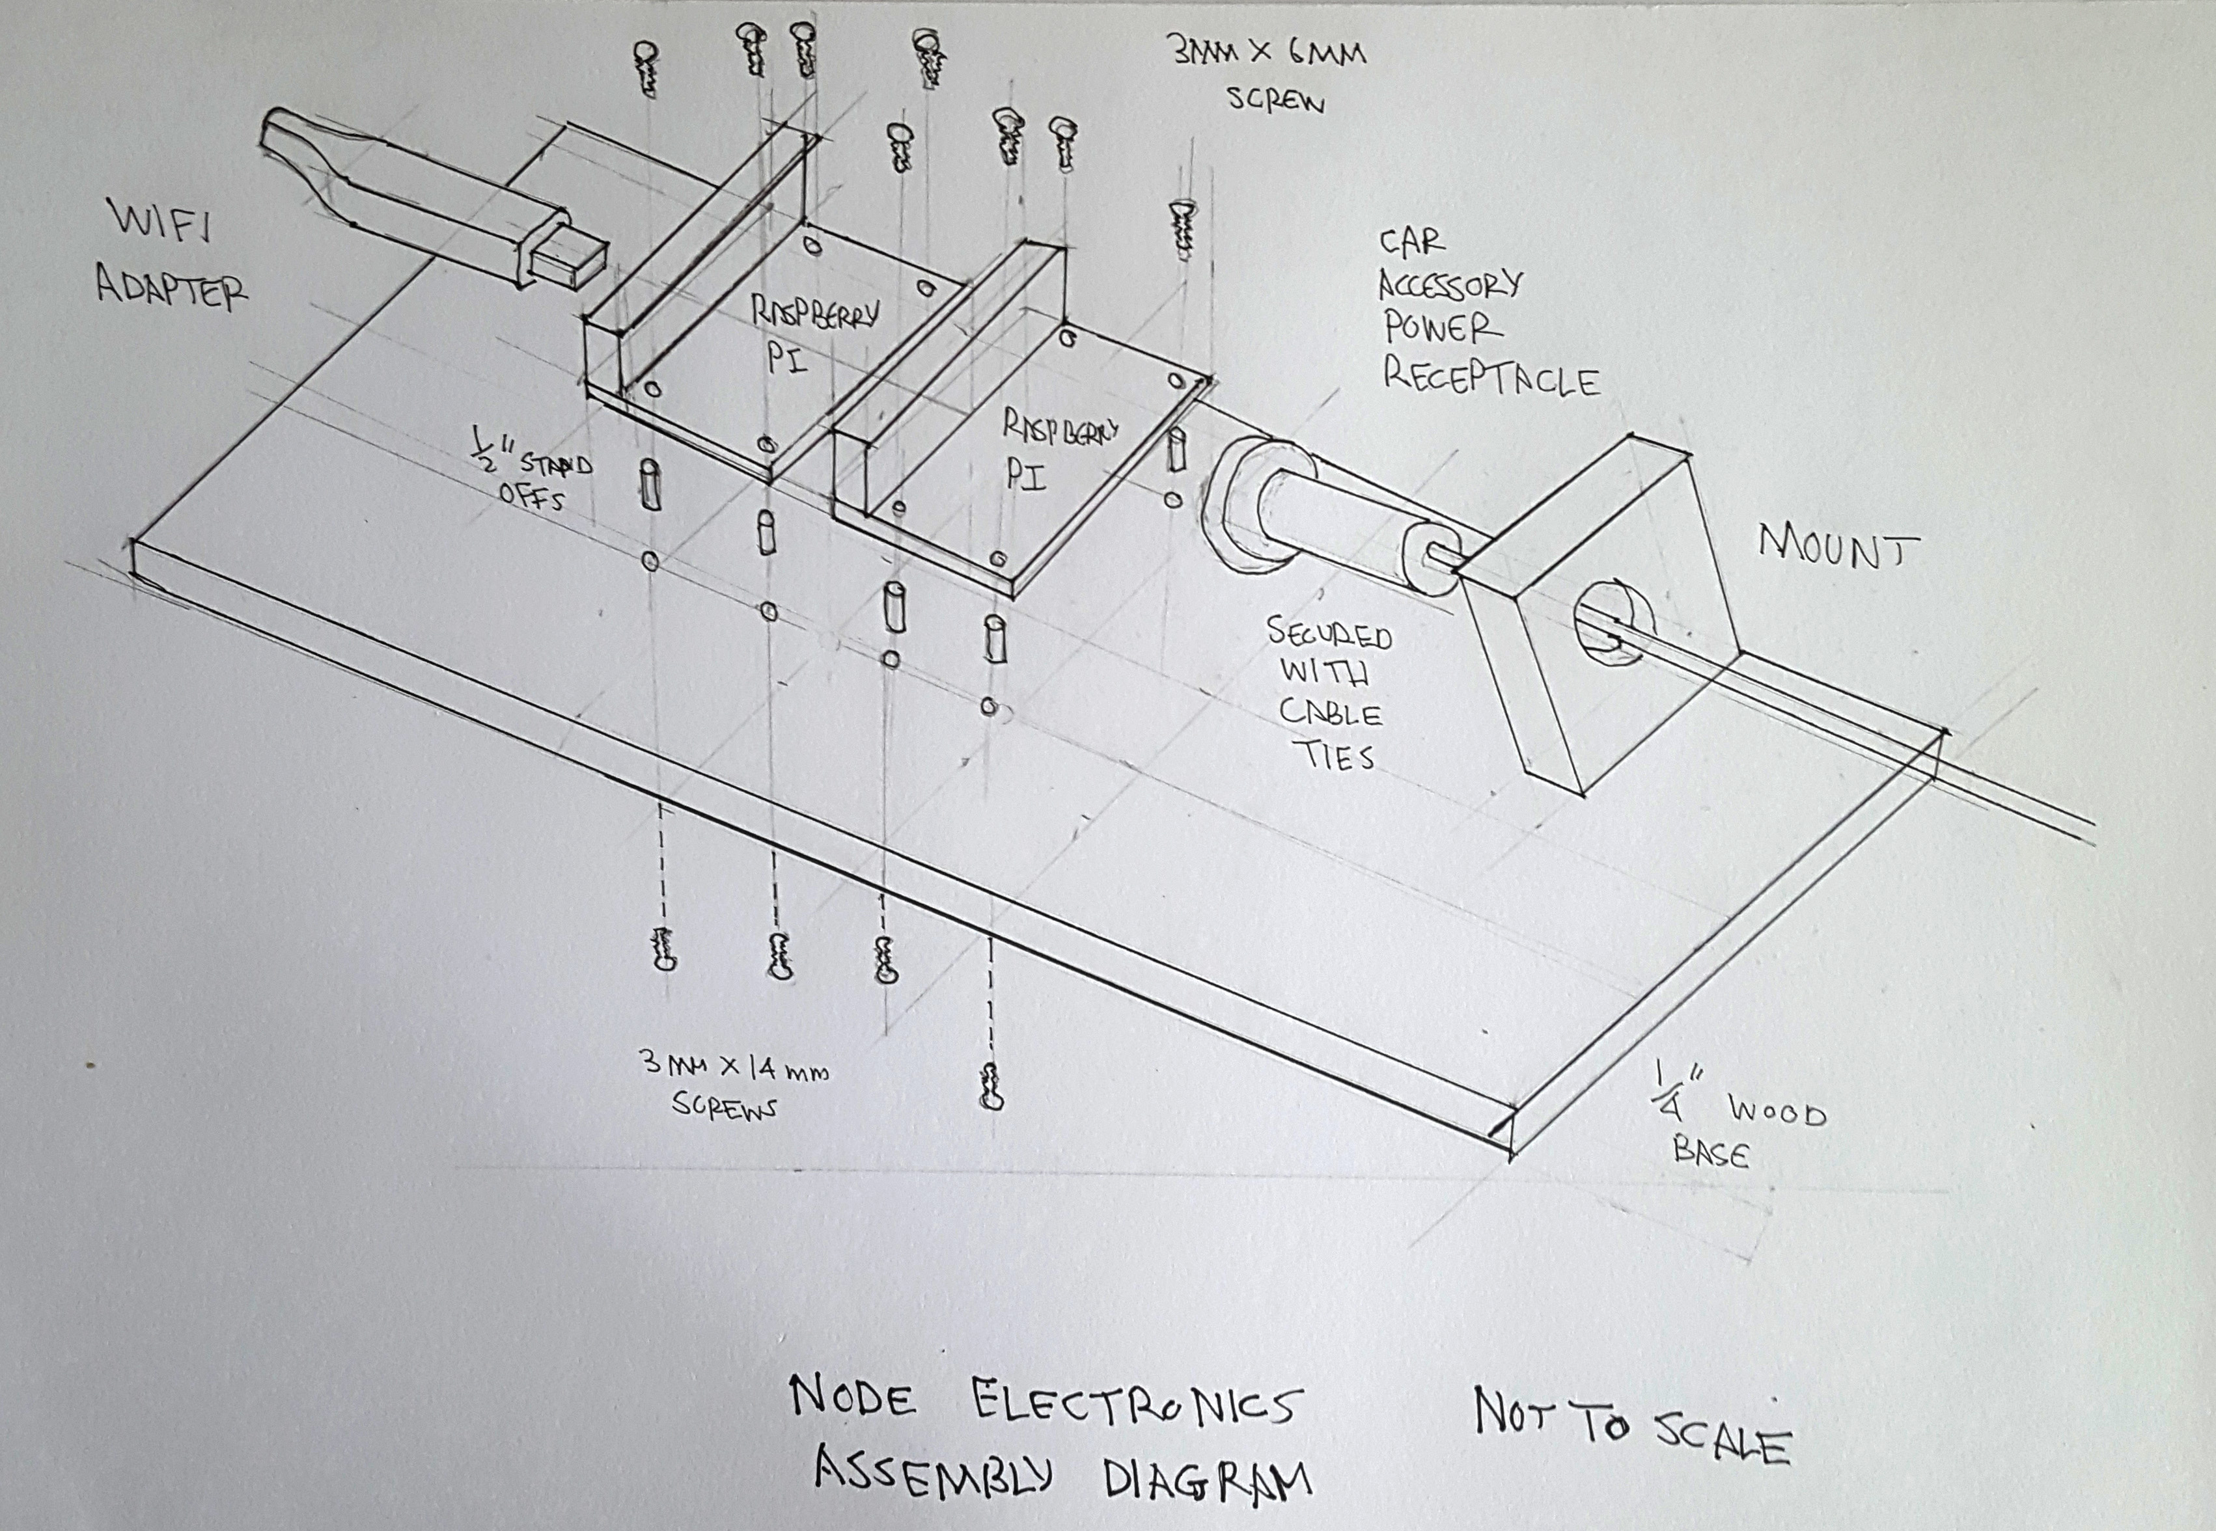

Assembly Diagram of Node Electronics

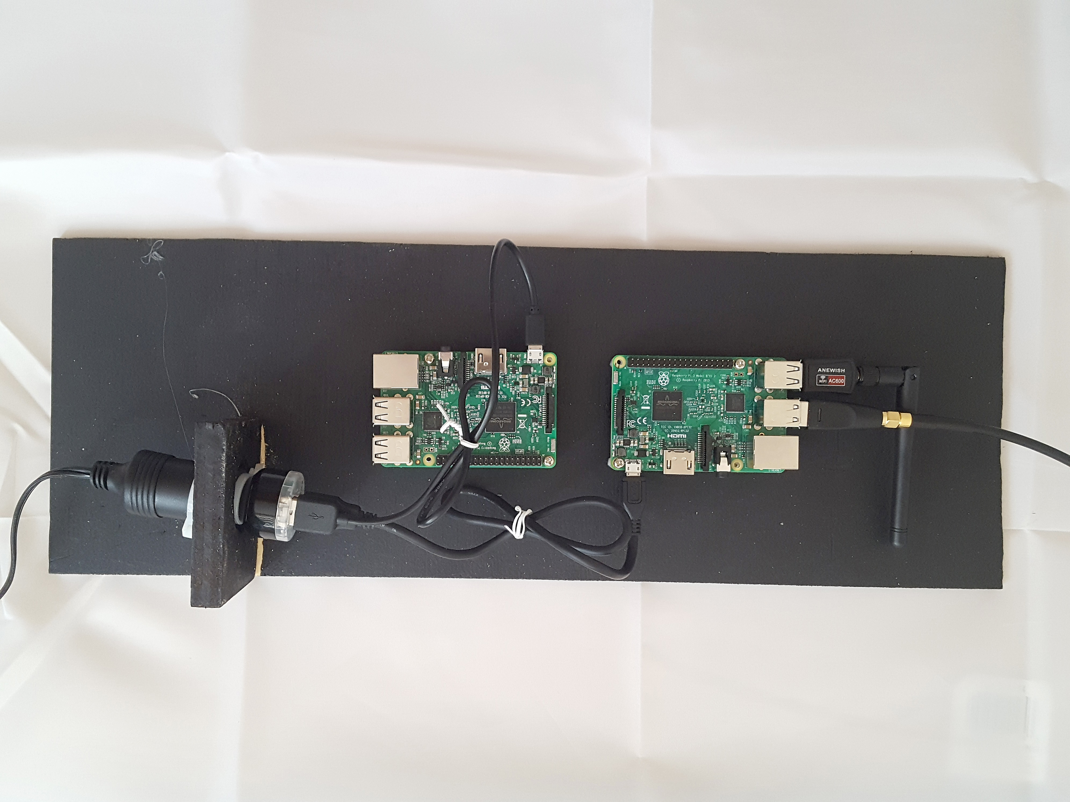

Electronics of node mounted to base that is inserted in the enclosure detailed plans.

Side view of electronics mounted to base.

This sub-assembly is contained in a box made out of wood. The top view and side view of the box is shown below.

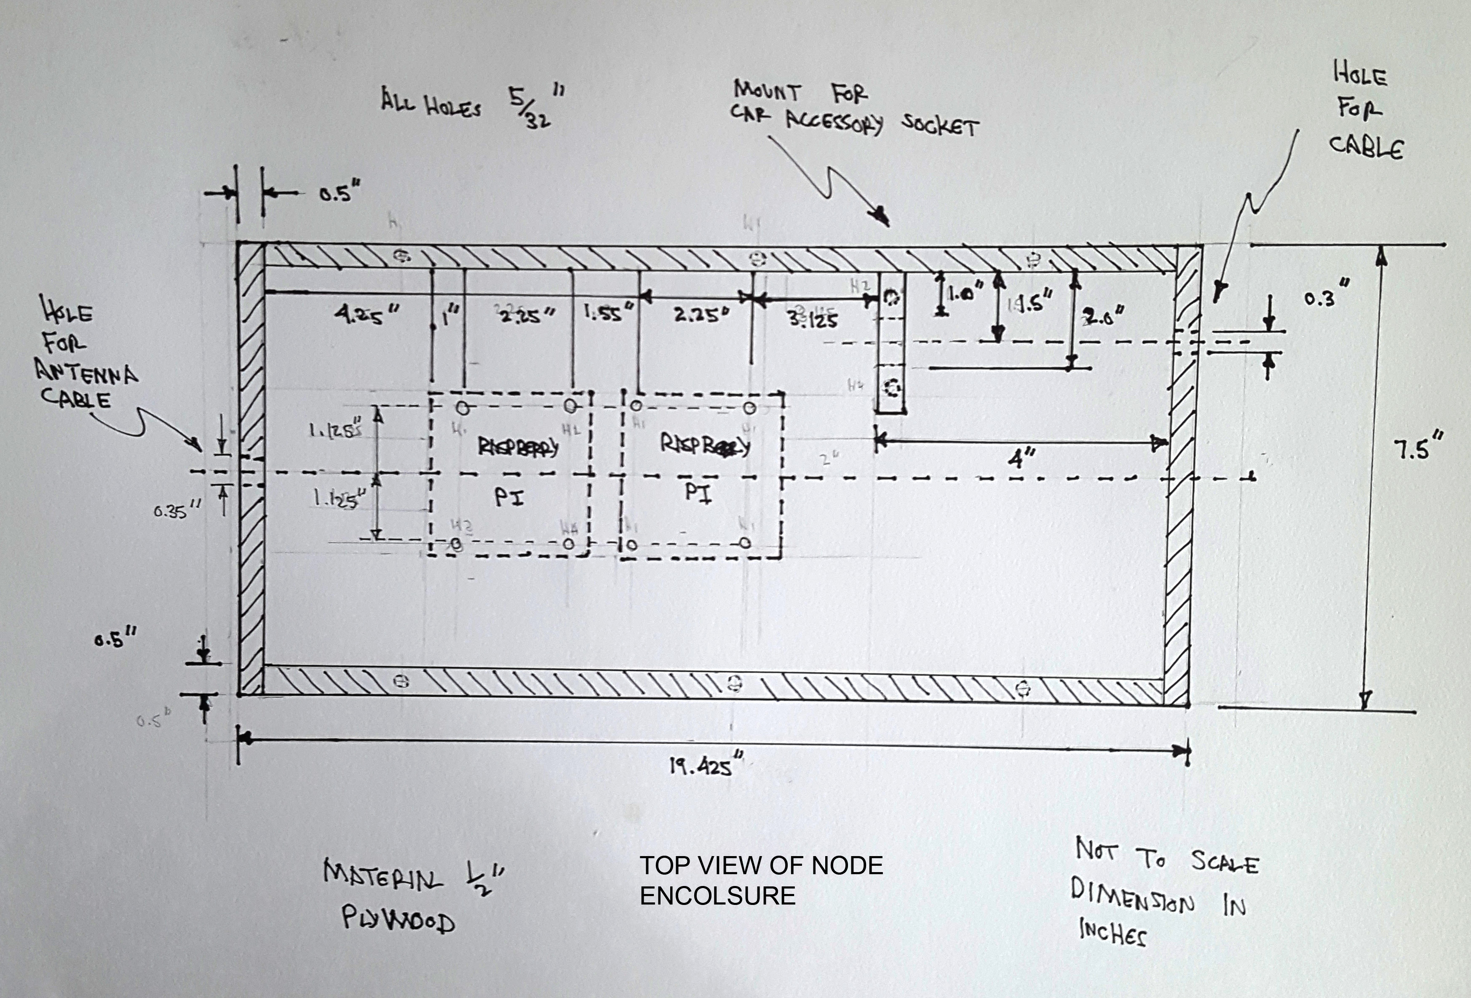

Top view of Node Enclousre

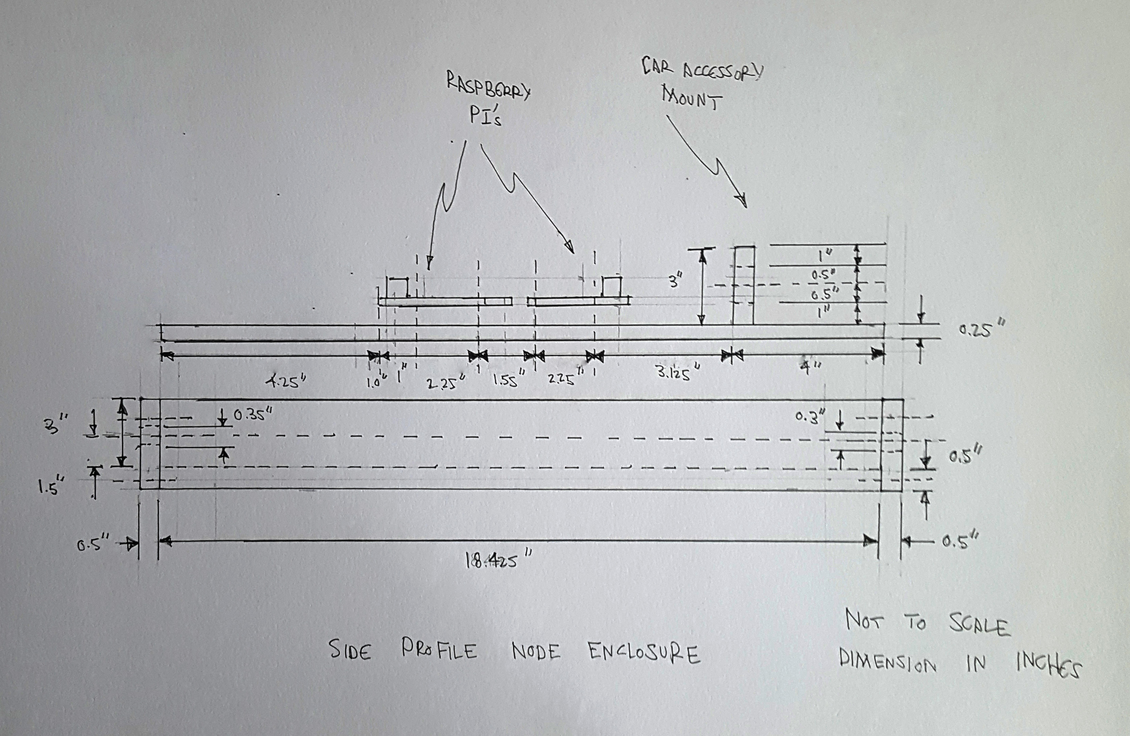
Side View of Node Enclosure
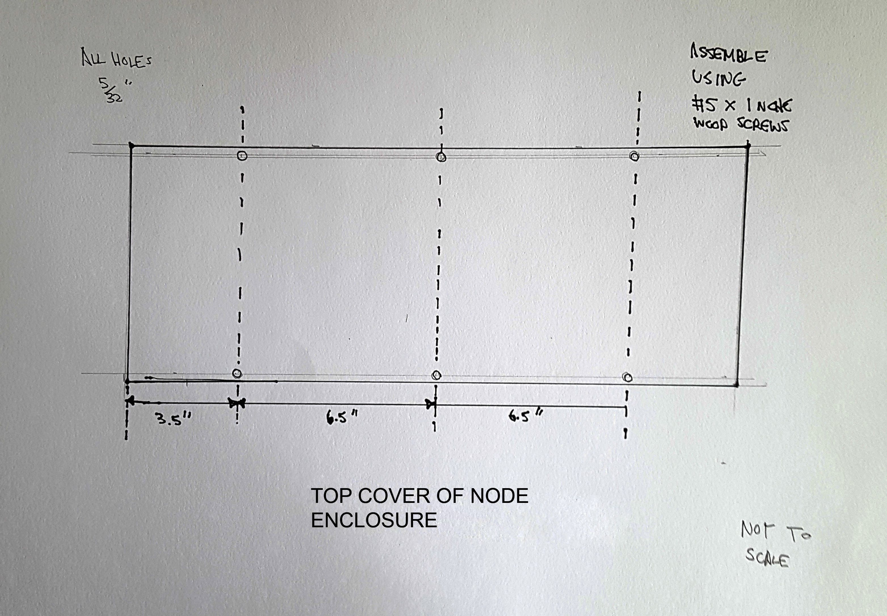

Top Cover of Node Enclosure

All the wooden pieces of the assembled using #5 x 1 inch wood screws.

Cables exit the enclosure at the top for the antenna and from the bottom for the power cable to the battery. The holes are sealed with silicone. The enclosure is sprayed with rubberized asphalt undercoating. This coating is used to coat the undersides of cars.



Rubberized Asphalt Spray

Appendix D: Parts List for Node Enclosure

Item # | Part Description | Number of units | Source | Cost
1 | Raspberry PI 2 B or 3 B | 1 or 2 units depending on whether a server is required for the node | https://www.adafruit.com/product/3055?src=raspberrypi | 2 x $35 = $70
2 | 32 gigabyte SD card for Raspbian Operating System | 1 | https://www.ebay.com/itm/2GB-miniSD-with-adapter-mini-SD-memory-card-64MB-128MB-256MB-512MB-1GB-available-/262350667719?hash=item3d15517fc7:g:Eh8AAOSw~bFWQUYj | 2 x $.799 = $15.98
3 | Ralink RT5370 USB WiFi adapter | 2 | https://www.ebay.com/p/150m-USB-WiFi-Wireless-LAN-Adapter-W-Antenna-Raspberry-Pi-Ralink-Rt5370-Maus/1284325483?iid=231562415076 | 2 x $6.88 = $13.76
4 | Dual Port USB Card Power Charger Adapter | 1 | http://www.ebay.ca/itm/Dual-2-Port-USB-Car-Power-Charger-Adapter-for-iPhone6-6PLUS-5S-iPod-Camera-New-/112591622449?var=&hash=item1a36fbd131 | $1.62
5 | 12V-10A-Car-Accessory-Cigarette-Lighter-Socket-Extension-Cord-Cable-1-5m | 1 | http://www.ebay.ca/itm/12V-10A-Car-Accessory-Cigarette-Lighter-Socket-Extension-Cord-Cable-1-5m-/311473720338?hash=item488547cc12:g:DbwAAOSwl9BWMIpr | $1.87
6 | ½ inch stand off | 8 | http://www.ebay.ca/itm/12V-10A-Car-Accessory-Cigarette-Lighter-Socket-Extension-Cord-Cable-1-5m-/311473720338?hash=item488547cc12:g:DbwAAOSwl9BWMIpr | 8 x $0.02 = $0.16
7 | 3mm x 6 mm screws with Phillips head | 8 | https://www.ebay.com/itm/RC-Screwz-Stainless-3mm-x-6mm-Socket-Head-Cap-Screw-15-Qty-/291057302994?epid=1855636020&hash=item43c45dfdd2:g:LDoAAOSwa-dWp~58 | 8 x $0.26 = $2.08
8 | 3 mm x 14 mm screws with Phillips head | 8 | https://www.ebay.com/itm/AHS-AHS-3X14BHSS-100-Stainless-Steel-Button-Head-Screw-3mm-x-14mm-A2-100-PCS-/263207766904?hash=item3d4867cb78:g:0zsAAOSw23lZux86 | 8 x $0.10 = $0.80
9 | #5 x 1 inch wood screws | 20 | https://www.ebay.com/itm/Vintage-SHS-5-X-1-Inch-FLAT-Head-Steel-Phillips-Wood-Screws-100-per-box-ZINC-/232496932268?hash=item3621e5a5ac:g:V7oAAOSwxN5WXI65 | 8 x $0.07 = $0.56
10 | 24 inch x 30 inch ½ inch plywood | 1 | http://www.rockler.com/baltic-birch-plywood-24-inch-x-30-inch | $15.99
11 | 24 inch x 30 inch 1.4 inch plywood (makes 3 base pieces) | 1 | http://www.rockler.com/baltic-birch-plywood-24-inch-x-30-inch | $14.16 / 3 = $4.72
 | TOTAL FOR NODE ENCLOSURE |  |  | $127.54 or $84.55

Parts List of Cantenna

Item Number # | Part | Number of Parts | Source | Cost
12 | 13 inch section of 4 inch heater duct (comes in 5 foot sections) | 1 | http://www.homedepot.com/p/4-in-x-5-ft-Round-Metal-Duct-Pipe-CP4X60/100196725 | $7.56 / 4 = $1.89
13 | 4 inch heater duct end cap | 1 | http://www.homedepot.com/p/Master-Flow-4-in-Round-Duct-Cap-DC4/100396932 | $4.18
14 | Chasis mount Male N-type connector | 1 | https://www.ebay.com/itm/1x-N-Type-Male-Plug-4-Hole-panel-Mount-flange-with-solder-cup-straight-connector-/191943309017?hash=item2cb0b676d9:g:~9gAAOSwV0RXq9XM | $3.80
15 | M2 bolts | 4 | https://www.ebay.com/itm/50Pc-Metric-M2-4-30mm-Stainless-Steel-Socket-Cap-Hex-Head-Screw-Bolt-socket-Head/332126790711?_trkparms=aid%3D555019%26algo%3DPL.BANDIT%26ao%3D1%26asc%3D41375%26meid%3D51312ed970ff4a67bd40eb29c8c964f2%26pid%3D100505%26rk%3D1%26rkt%3D1%26&_trksid=p2045573.c100505.m3226 | 4 x $0.06 = $0.24
16 | M2 nuts | 4 | https://www.ebay.com/itm/100pcs-M2-M3-M4-M6-Hex-Screw-Nut-Steel-Hexagon-Galvanized-Nuts-NEW-DIY-Craft-/121999369069?var=&hash=item1c67baa36d:m:mnT9Q7CYFJnxhbLgmomTezQ | 4 x $0.02 = $0.08
17 | ¼”-20 bolt 1 ¼ long | 1 | https://www.ebay.com/itm/1-4-20-Hex-Head-Cap-Screws-Tap-Bolts-304-Stainless-Steel-Fully-Threaded-Qty-25/231325433106?_trkparms=aid%3D555019%26algo%3DPL.BANDIT%26ao%3D1%26asc%3D41375%26meid%3D1c5555ebee90427cabd1f06772482f70%26pid%3D100505%26rk%3D1%26rkt%3D1%26&_trksid=p2045573.c100505.m3226 | 1 x $.20 = $0.20
18 | ¼”-20 nut | 1 | https://www.ebay.com/itm/Qty-100-Stainless-Steel-Finished-Finish-Hex-Nuts-1-4-20-/361271504137?hash=item541d75ad09:g:g~MAAOSwfrJZxBRo | $0.06
19 | 2 flat washers | 2 | https://www.ebay.com/itm/1-4-20-Steel-Flat-Washer-Qty-20-/201714175593?hash=item2ef71a0e69:g:214AAOSwcUBYI6f7 | 2 x $0.08 = $0.16
20 | Male N-type connect to SMA cable | 1 | https://www.ebay.com/itm/N-Type-Male-to-SMA-Male-2-Meters-Antenna-Coaxial-RG58-Cable-Connector-S6W8-/253139259998?epid=2186959186&hash=item3af046925e:g:MzQAAOSwEQFZsMRO | $3.51
21 | 1.75 inches of 22 gauge wire |  |  | $1.00
 | TOTAL |  |  | $15.12

List of Part for Power System

Part # | Description | Quantity | Source | Cost
22 | Trojan T-145 6 volt battery  or Trojan 12V 225Ah J185H-AC Deep Cycle Flooded Lead Acid Battery | 1 | https://www.ebay.com/itm/Trojan-T-145-6v-6-volt-260-Amp-hour-Golf-Cart-Lead-Acid-deep-cycle-battery-260a-/302240686413?hash=item465ef2e14d:g:ZhYAAOSwZ8ZW~bQL  https://www.ebay.com/itm/Trojan-12V-225Ah-J185H-AC-Deep-Cycle-Flooded-Lead-Acid-Battery-/271860110985?epid=2254328497&hash=item3f4c201689:g:AjMAAOSwlV9WS6IP | $239 or $299
 | Charging Circuit for battery
23 | IN4007 Diode | 1 | https://www.digikey.com/product-detail/en/vishay-semiconductor-diodes-division/1N4007-E3-54/1N4007-E3-54GICT-ND/868990 | $0.23
24 | LM317 Adjustable voltage regulator | 1 | https://www.amazon.com/Major-Brands-LM317T-Standard-Regulator/dp/B00B886Y9E | $1.79
25 | 10 ohm 1 watt resistor | 1 | http://www.ebay.ca/itm/Resistor-1-Watt-Metal-Film-Resistors-10-ohm-1-2-Canada-Free-Shipping-/162694016819?hash=item25e151af33:g:lEcAAOSwIgNXt910 | $5.00
26 | 6.8 volt 1 watt zener diode or 14.4 volt 1 watt zener diode |  | http://www.mouser.com/ProductDetail/Central-Semiconductor/1N4736A-TR/?qs=sGAEpiMZZMtQ8nqTKtFS%2fNTW9pm8IdF6c88iHX0LMfvEZULAhgbm%252bg%3d%3d  http://ca.mouser.com/ProductDetail/Nexperia/NZX14C133/?qs=sGAEpiMZZMtQ8nqTKtFS%2fISyHb0gtGyWNoSAU6Ved%252bE%3d | $0.36 or $.27
27 | 2N2222A NPN switching transistor | 1 | https://www.digikey.com/product-detail/en/central-semiconductor-corp/2N2222A/2N2222ACS-ND/4806845 | $2.23
28 | 1 kilohm potentiometer | 1 | https://www.jameco.com/z/55PR2-5K-RJ11CP252--BI-Technologies-1-1-4-Inch-Rectangular-Cermet-Potentiometer-2-5K-Ohms-1-Watt-10-22-Turns-Thru-Hole-Side-Adjust_2201148.html | $6.95
29 | Solar Arrays | 1 or 2 | https://www.harborfreight.com/100-watt-solar-panel-kit-63585.html | $145 or $290
 | TOTAL |  |  | $460.56 or 605.56

Warren A Kaplan. “Can the ubiquitous power of mobile phones be used to improve health outcomes in developing countries?”. 23 May 2006. https://globalizationandhealth.biomedcentral.com/articles/10.1186/1744-8603-2-9
Carole Déglise;L. Suzanne Suggs3; Peter Odermatt. “Short Message Service (SMS) Applications for Disease Prevention in Developing Countries”. J Med Internet Res 2012;14(1):e3 . http://www.jmir.org/2012/1/e3/
Carole Déglise; , L Suzanne Suggs; Peter Odermatt. “SMS for disease control in developing countries: a systematic review of mobile health applications”. Published July 23, 2012. http://journals.sagepub.com/doi/abs/10.1258/jtt.2012.110810
Presentation by Serval.
:”Africa’s Mobile Economic Revolution”. The Observer. https://www.theguardian.com/technology/2011/jul/24/mobile-phones-africa-microfinance-farming “
“Metal Theft in South Africa”. Nov 21, 2016. http://www.tdworld.com/substations/metal-theft-south-africa
“Protecting Africa’s telecom infrastructure”. http://www.africatelecomit.com/protecting-africas-telecom-infrastructure
https://play.google.com/store/apps/details?id=com.opengarden.firechat&hl=en
Margaret Rouse “asymmetric cryptography (public key cryptography)”. http://searchsecurity.techtarget.com/definition/asymmetric-cryptography
Margaret Rouse “asymmetric cryptography (public key cryptography)”. http://searchsecurity.techtarget.com/definition/asymmetric-cryptography
Margaret Rouse “asymmetric cryptography (public key cryptography)”. http://searchsecurity.techtarget.com/definition/asymmetric-cryptography
https://security.stackexchange.com/questions/8034/how-digital-signature-verification-process-works
https://en.wikipedia.org/wiki/XMPP
https://xmpp.org/
http://www.bing.com/search?q=tls+transmission&src=IE-TopResult&FORM=IETR02&conversationid=
http://www.bing.com/search?q=SSL+transmission&src=IE-TopResult&FORM=IETR02&conversationid=
https://en.wikipedia.org/wiki/Pretty_Good_Privacy
https://gnupg.org/
Michael Cobb. “How symmetric and asymmetric encryption algorithms differ “ http://webcache.googleusercontent.com/search?q=cache:U44GZ6TA7g8J:searchsecurity.techtarget.com/answer/What-are-the-differences-between-symmetric-and-asymmetric-encryption-algorithms+&cd=17&hl=en&ct=clnk&gl=ca
Michael Cobb. “How symmetric and asymmetric encryption algorithms differ “ http://webcache.googleusercontent.com/search?q=cache:U44GZ6TA7g8J:searchsecurity.techtarget.com/answer/What-are-the-differences-between-symmetric-and-asymmetric-encryption-algorithms+&cd=17&hl=en&ct=clnk&gl=ca
Michael Cobb. “How symmetric and asymmetric encryption algorithms differ “ http://webcache.googleusercontent.com/search?q=cache:U44GZ6TA7g8J:searchsecurity.techtarget.com/answer/What-are-the-differences-between-symmetric-and-asymmetric-encryption-algorithms+&cd=17&hl=en&ct=clnk&gl=ca
https://crypto.stackexchange.com/questions/2887/difference-between-encrypting-something-and-hashing-something
https://stackoverflow.com/questions/18257185/how-does-a-public-key-verify-a-signature
“How To Increase WiFi Range With The Right WiFi Antenna”. July 19, 2014. https://learntomato.com/how-to-increase-wifi-range-with-the-right-wifi-antenna/
Saad Chdhry. “How Cantenna Works [Technically].”. https://propakistani.pk/2010/03/19/how-cantenna-works-technically/
Saad Chdhry. “How Cantenna Works [Technically].”. https://propakistani.pk/2010/03/19/how-cantenna-works-technically/
Sven-Erik Zetterström. “Cantenna the Poor Wifi Hackers Choice”. https://books.google.ca/books?id=7HNQDQAAQBAJ&pg=PT8&lpg=PT8&dq=large+diameter+cantenna&source=bl&ots=FT2hjm941c&sig=R6-nIGb9FLa6aJeilNkTHRxozvM&hl=en&sa=X&ved=0ahUKEwiI65v09OLWAhVGjFQKHa7fB9AQ6AEIRjAI#v=onepage&q=large%20diameter%20cantenna&f=false .
https://www.lifewire.com/wifi-channel-number-change-to-avoid-interference-818208
http://web.archive.org/web/20080316034408/http://www.pelaginox.com/pc/pc-cancalc.html
https://books.google.ca/books?id=7HNQDQAAQBAJ&pg=PT8&lpg=PT8&dq=large+diameter+cantenna&source=bl&ots=FT2hjm941c&sig=R6-nIGb9FLa6aJeilNkTHRxozvM&hl=en&sa=X&ved=0ahUKEwiI65v09OLWAhVGjFQKHa7fB9AQ6AEIRjAI#v=onepage&q=large%20diameter%20cantenna&f=false
IEEE 802.11-2007: Wireless LAN Medium Access Control (MAC) and Physical Layer (PHY) specifications". IEEE. 8 March 2007.
http://www.electroschematics.com/4746/solar-charger-circuit
https://www.raspberrypi.org/help/faqs/
http://www.solartechnology.co.uk/support-centre/calculating-your-solar-requirments
https://www.altestore.com/store/deep-cycle-batteries/flooded-lead-acid-batteries/mk-8l16ltp-fla-370-ah-20hr6v-ltp-terminal-p4115/
https://www.lithiumion-batteries.com/products/12v-300ah-lithium-ion-battery/12v-300ah-lithium-ion-battery.php
https://www.radiolabs.com/products/antennas/accessories/lightning-protection.php
https://www.airwaveadvisors.com/how-much-does-a-cell-tower-cost/
https://www.quora.com/How-much-money-would-it-cost-to-build-a-cell-tower
https://www.quora.com/What-is-a-cell-towers-range
https://www.quora.com/What-is-a-cell-towers-range
https://xmpp.org/about/technology-overview.html m
https://en.wikipedia.org/wiki/Pretty_Good_Privacy

